**VISVESVARAYA** **TECHNOLOGICAL** **UNIVERSITY**



**“JnanaSangama”,** **Belgaum** **-590014,** **Karnataka.**

**LAB** **REPORT**

on

OBJECT ORIENTED JAVA PROGRAMMING

***Submitted*** ***by***

**SRINIDHI B V**  **(1BM23CS339)**

***in*** ***partial*** ***fulfillment*** ***for*** ***the*** ***award*** ***of*** ***the*** ***degree*** ***of***

**BACHELOR** **OF** **ENGINEERING**

***in***

**COMPUTER** **SCIENCE** **AND** **ENGINEERING**

**B.M.S.** **COLLEGE** **OF** **ENGINEERING**

**(Autonomous** **Institution** **under** **VTU)**

BENGALURU-560019 Sep 2024-Jan 2025

B. M. S. College of Engineering,



**Bull** **Temple** **Road,** **Bangalore** **560019**

(Affiliated To Visvesvaraya Technological University, Belgaum)

**Department** **of** **Computer** **Science** **and** **Engineering**

**CERTIFICATE**

This is to certify that the Lab work entitled “**OBJECT** **ORIENTED** **JAVA** **PROGRAMMING**” carried out by **SRINIDHI** **B** **V(1BM23CS339),** who is bonafide student of **B.** **M.** **S.** **College** **of** **Engineering.** It is in partial fulfillment for the award of **Bachelor** **of** **Engineering** **in** **Computer** **Science** **and** **Engineering** of the Visvesvaraya Technological University, Belgaum during the year 2024-

25. The Lab report has been approved as it satisfies the academic requirements in respect of **Object-** **Oriented** **Java** **Programming** **Lab** **-** **(23CS3PCOOJ)** work prescribed for the said degree.

**Dr.** **Nandhini** **Vineeth** **Dr.** **Kavitha** **Sooda**

Associate Professor, Professor and Head,

Department of CSE, Department of CSE

BMSCE, Bengaluru BMSCE, Bengaluru

**INDEX**

|  |  |  |  |
| --- | --- | --- | --- |
| **Sl.** **No.** | **Date** | **Experiment** **Title** | **Page** **No.** |
| 1 | 26/09/2024 | Quadratic Equation Solution | 1-5 |
| 2 | 03/10/2024 | SGPA Calculation | 6-10 |
| 3 | 19/10/2024 | Library program: demonstration of toString() method | 11-16 |
| 4 | 24/10/2024 | Abstract Class demonstration program | 17-21 |
| 5 | 07/11/2024 | Inheritance demonstration program | 22-31 |
| 6 | 14/11/2024 | Packages in java demonstration | 32-41 |
| 7 | 21/11/2024 | Exception handling | 42-45 |
| 8 | 28/11/2024 | Multithreaded Programming | 46-50 |
| 9 | 19/12/2024 | Open ended exercise-1: Event Handling | 51-57 |
| 10 | 19/12/2024 | Open ended exercise-2: IPC and Deadlock | 58-69 |

Github Link : https://github.com/srinidhibv1403/1BM23CS339-OOJ

# LABORATORY PROGRAM – 1

Develop a Java program that prints all real solutions to the quadratic equation ax2 +bx+c = 0. Read in a, b, c and use the quadratic formula. If the discriminate b2 -4ac is negative, display a message stating that there are no real solutions.

**OBSERVATION** **:**

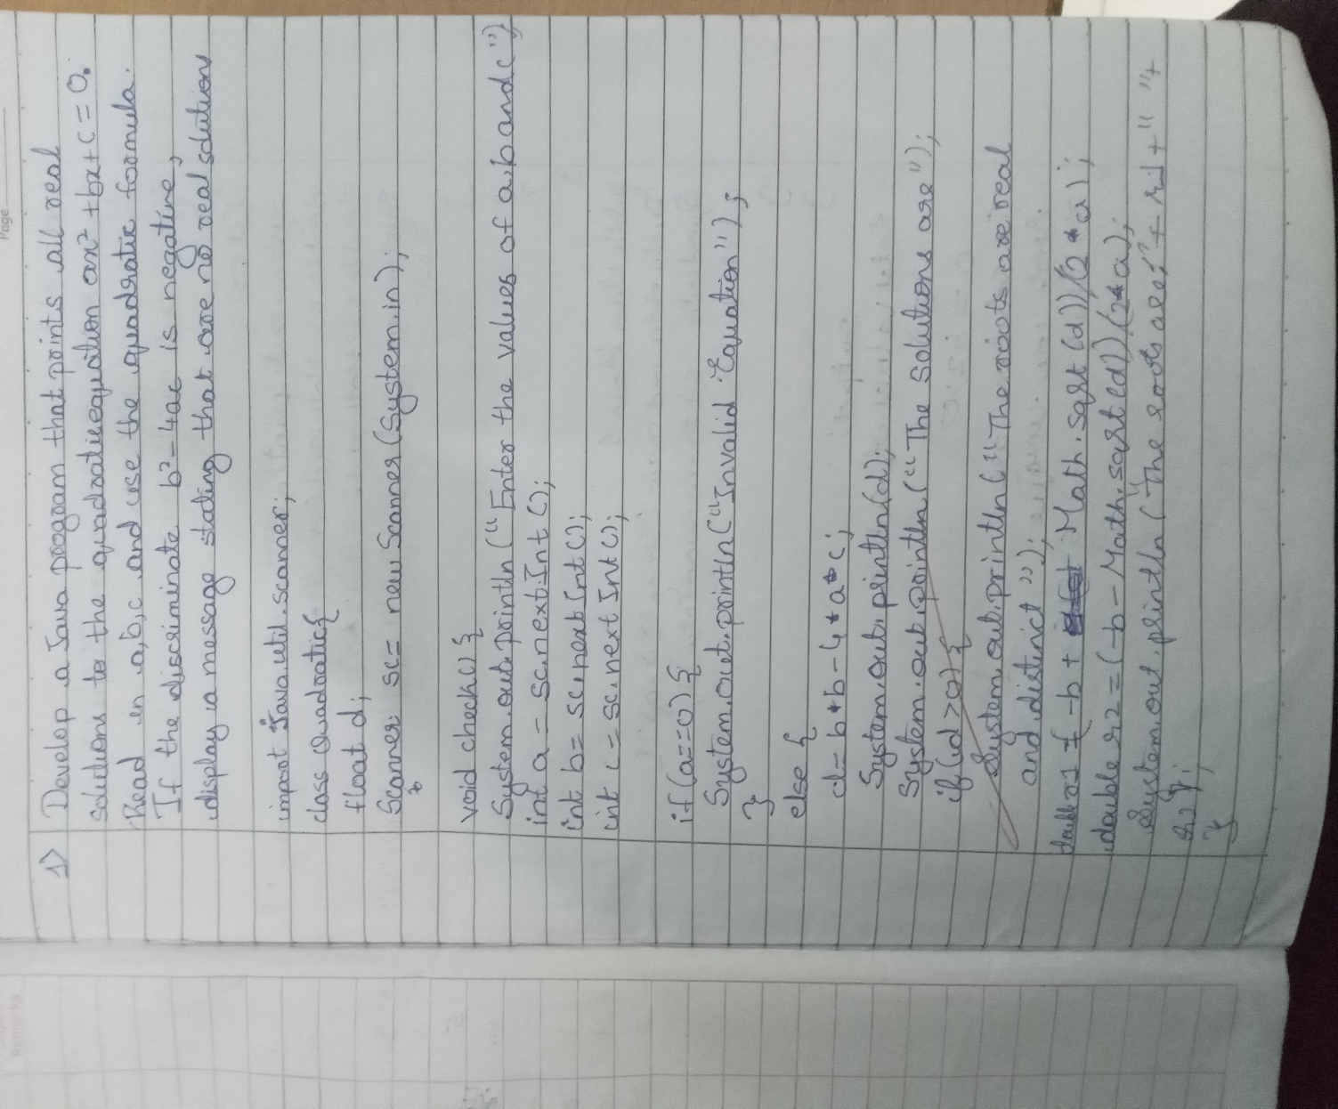

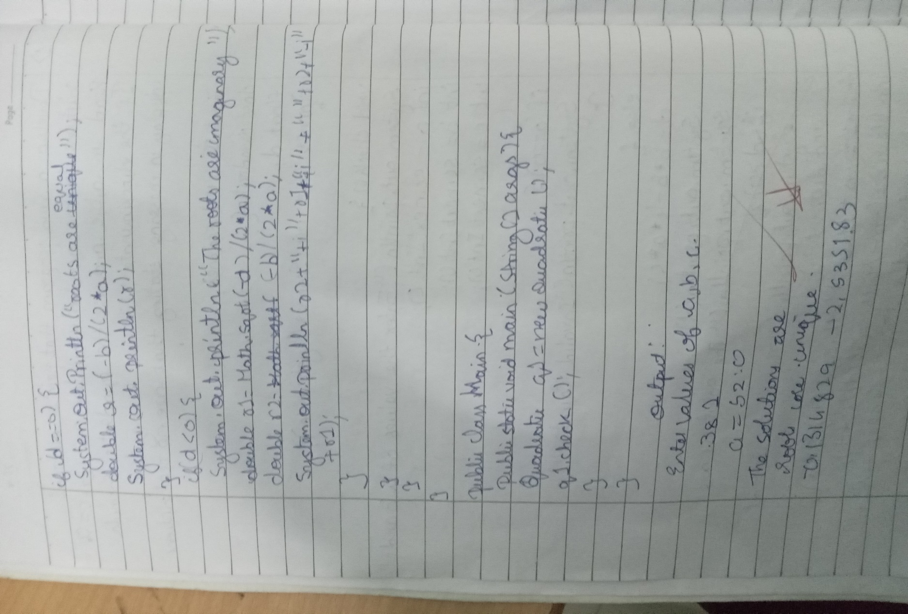

**CODE** **:**

import java.util.Scanner;

public class QuadraticEquationSolver { public static void main(String[] args) {

Scanner scanner = new Scanner(System.in);

System.out.print("Enter the coefficient a: "); double a = scanner.nextDouble();

System.out.print("Enter the coefficient b: "); double b = scanner.nextDouble();

System.out.print("Enter the coefficient c: "); double c = scanner.nextDouble();

**double** **discriminant** **=** **b** **\*** **b** **-** **4** **\*** **a** **\*** **c;**

if (discriminant > 0) {

double root1 = (-b + Math.sqrt(discriminant)) / (2 * a); double root2 = (-b - Math.sqrt(discriminant)) / (2 * a);

System.out.println("The equation has two real and distinct solutions:");

System.out.println("Root 1: " + root1); System.out.println("Root 2: " + root2);

} else if (discriminant == 0) {

**double** **root** **=** **-b** **/** **(2** **\*** **a);**

System.out.println("The equation has one real solution (a double root):");

System.out.println("Root: " + root);

**}** **else** **{**

System.out.println("The equation has no real solutions.");

**}**

scanner.close();

**}**

**}**

**OUTPUT** **:**

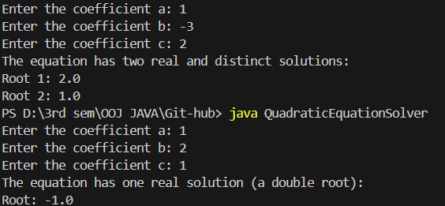

# LABORATORY PROGRAM – 2

Develop a Java program to create a class Student with members usn, name, an array credits and an array marks. Include methods to accept and display details and a method to calculate SGPA of a student.

**OBSERVATION** **:**

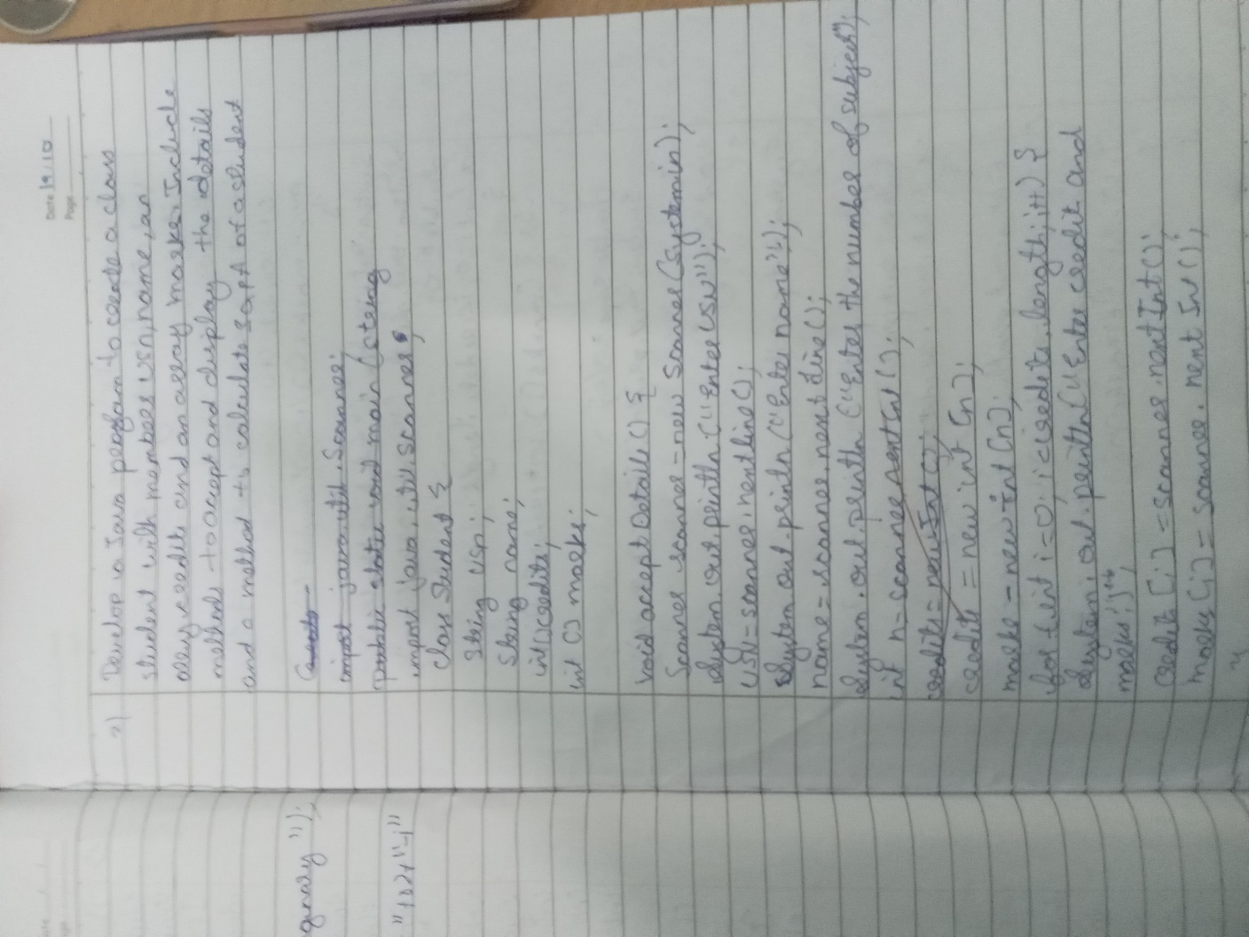

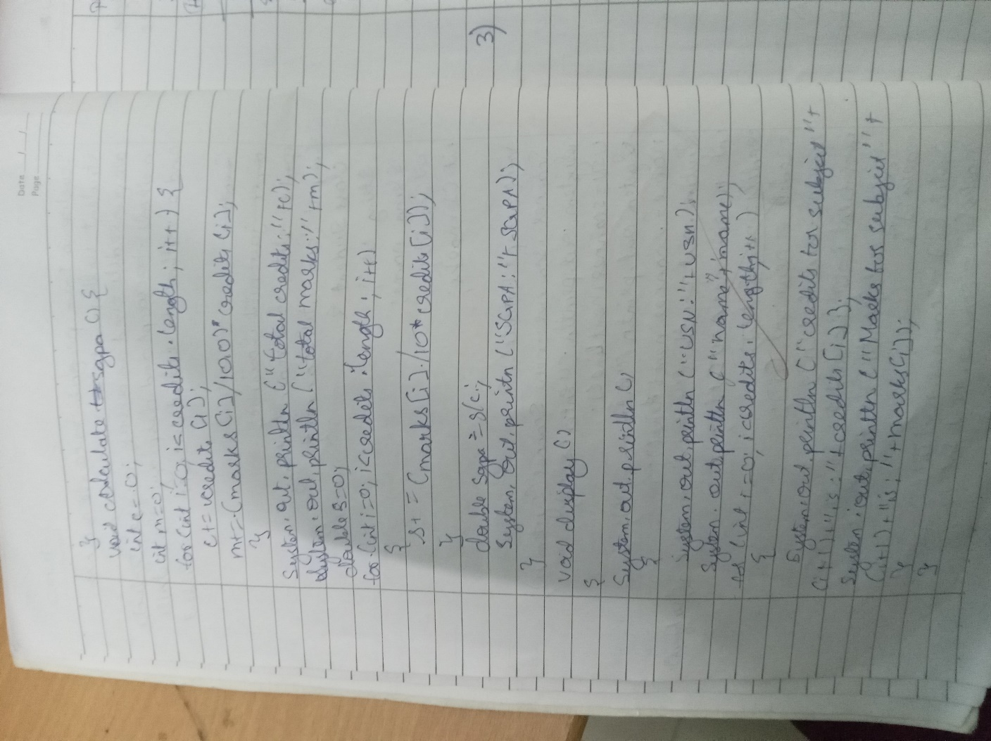

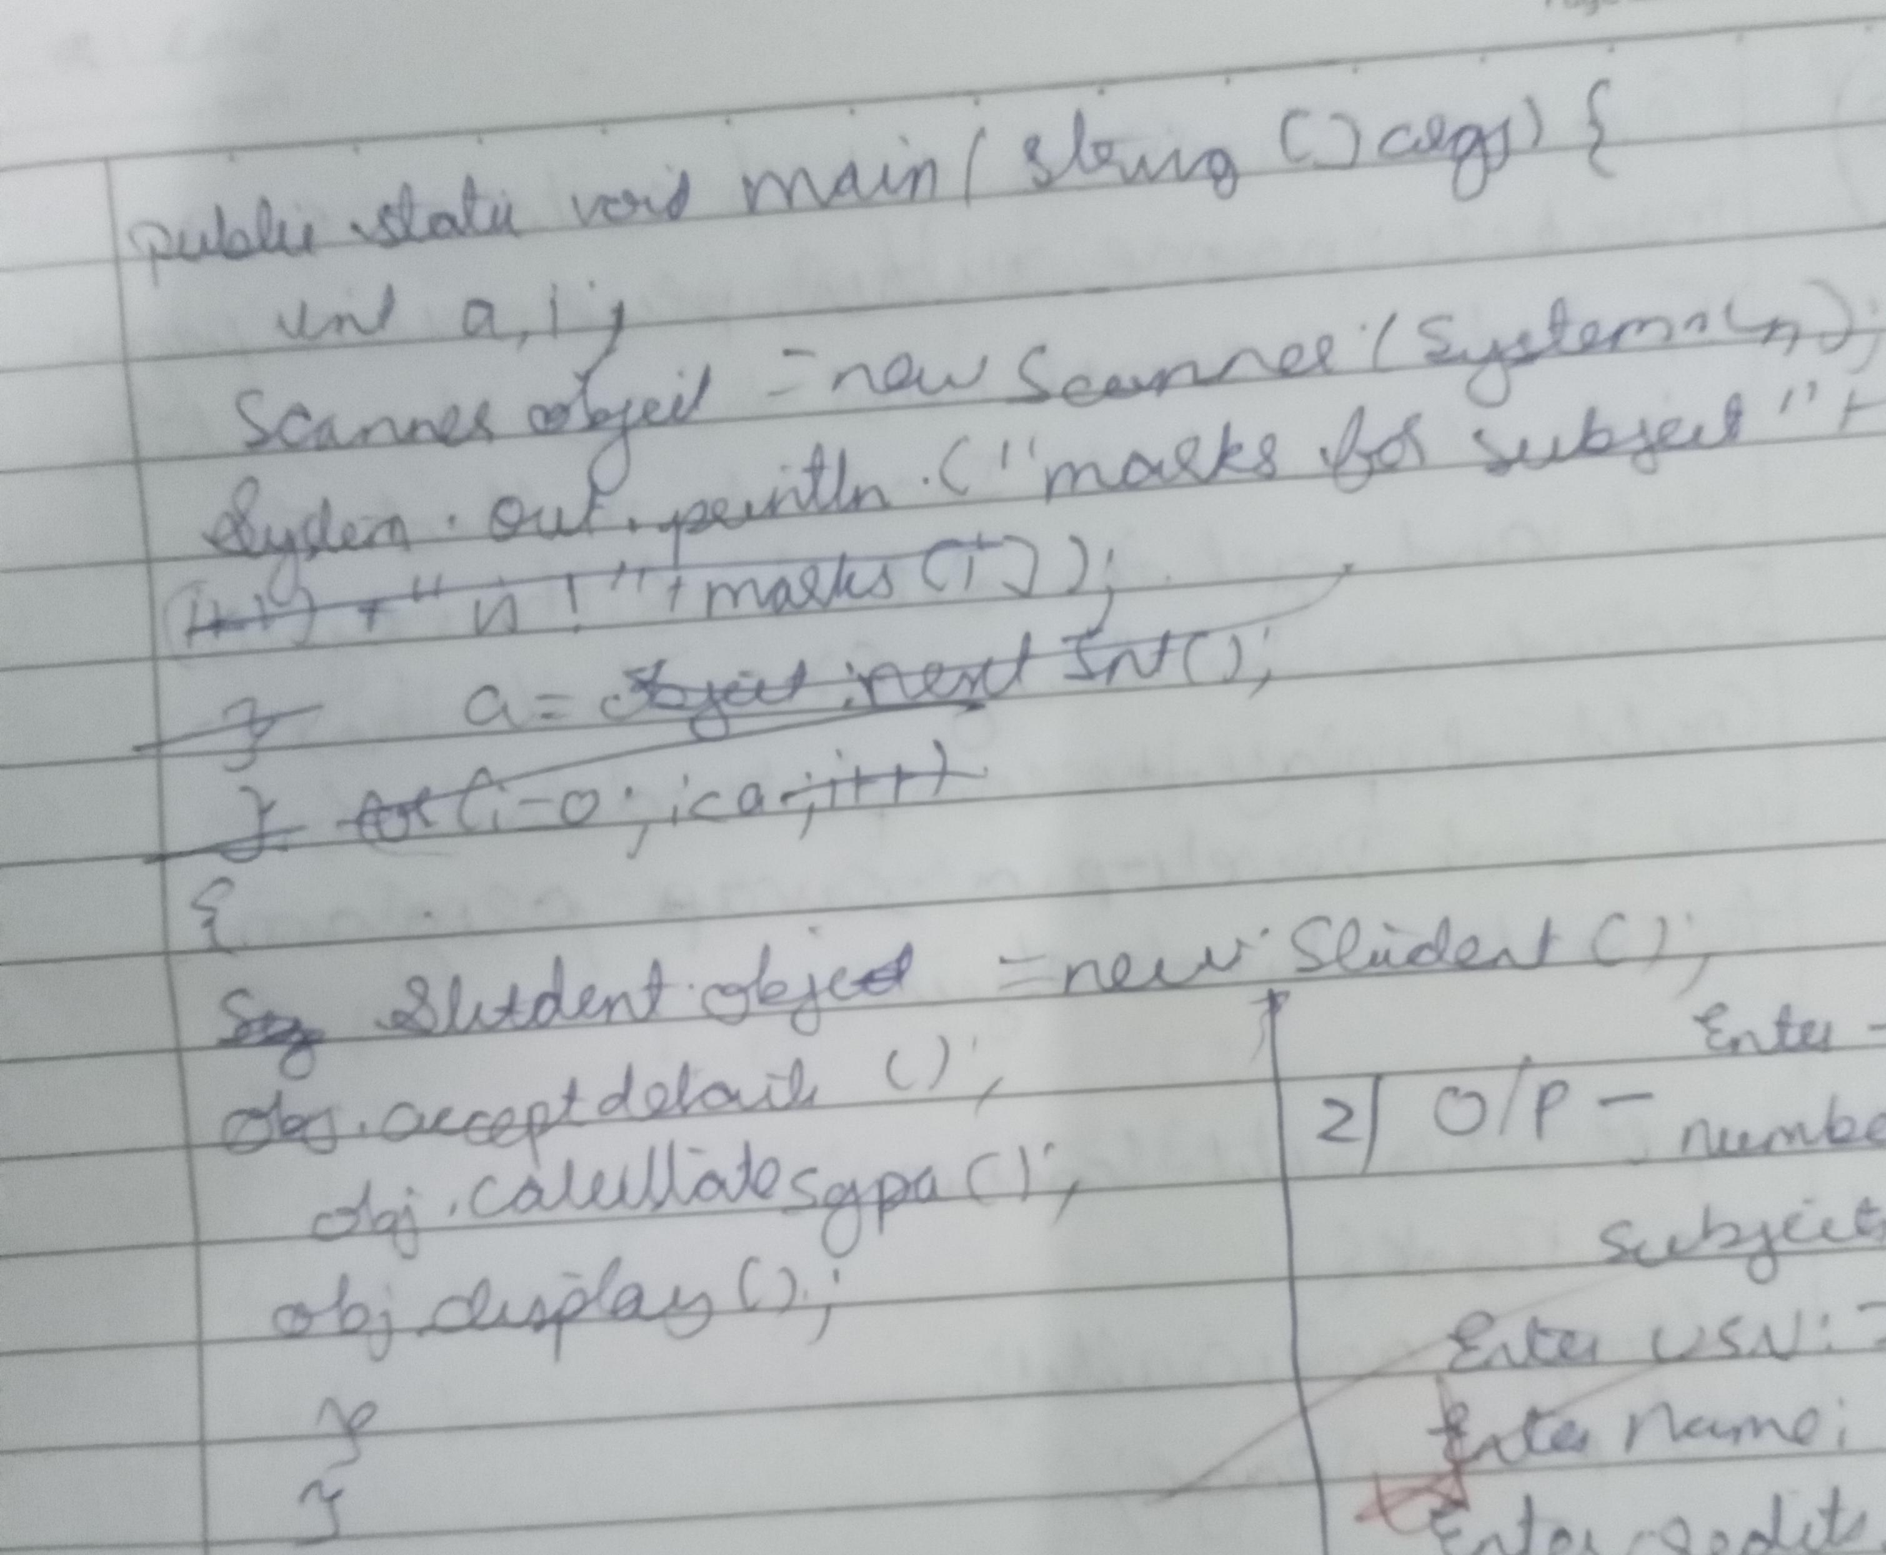

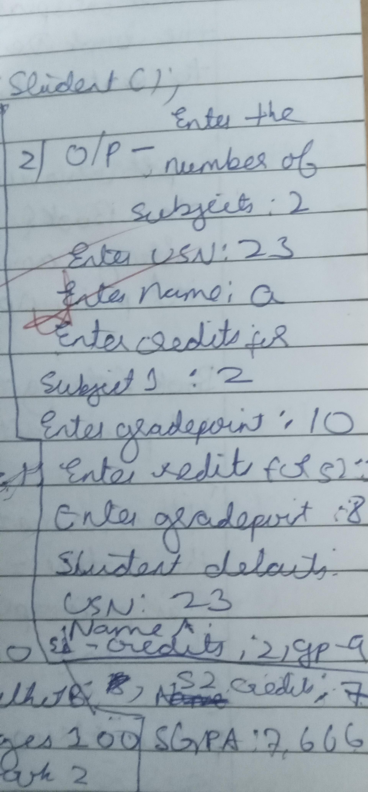

**CODE** **:**

import java.util.Scanner; class Student {

String usn; String name; double[] credits; double[] marks; int numSubjects

Student(int numSubjects) { this.numSubjects = numSubjects; credits = new double[numSubjects]; marks = new double [numSubjects];

}

public void acceptDetails() {

Scanner scanner = new Scanner(System.in); System.out.print("Enter USN: ");

usn = scanner.nextLine(); System.out.print("Enter Name: "); name = scanner.nextLine();

for (int i = 0; i < numSubjects; i++) { System.out.print("Enter credits for subject " + (i+1) + ": "); credits[i] = scanner.nextDouble();

System.out.print("Enter marks for subject " + (i+1) + ": ");

marks[i] = scanner.nextDouble();}} public void displayDetails() {

System.out.println("\nStudent Details:"); System.out.println("USN: " + usn); System.out.println("Name: " + name); System.out.println("Subjects Details: "); for (int i = 0; i < numSubjects; i++) {

System.out.println("Subject " + (i+1) + ": Credits = " + credits[i] + ", Marks = " + marks[i]);} }

public void calculateSGPA() { double totalCredits = 0; double totalGradePoints = 0;

for (int i = 0; i < numSubjects; i++) {

double gradePoint = getGradePoint(marks[i]); totalGradePoints += gradePoint * credits[i]; totalCredits += credits[i];

}

double sgpa = totalGradePoints / totalCredits; System.out.println("SGPA: " + sgpa);}

private double getGradePoint(double marks) { if (marks >= 90) return 10;

else if (marks >= 80) return 9; else if (marks >= 70) return 8;

else if (marks >= 60) return 7; else if (marks >= 50) return 6; else if (marks >= 40) return 5; else return 0; }

public class StudentMain {

public static void main(String[] args) { Student student = new Student(3); student.acceptDetails(); student.displayDetails(); student.calculateSGPA();

}

}

**OUTPUT** **:**

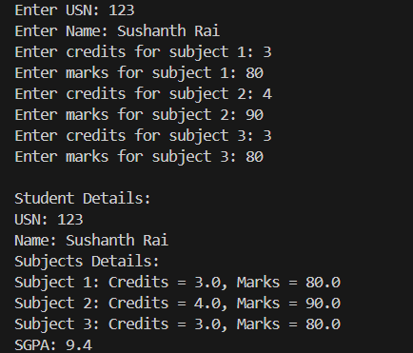

# LABORATORY PROGRAM – 3

Create a class Book which contains four members: name, author, price, num_pages. Include a constructor to set the values for the members. Include methods to set and get the details of the objects. Include a toString( ) method that could display the complete details of the book. Develop a Java program to create n book objects.

**OBSERVATION** **:**

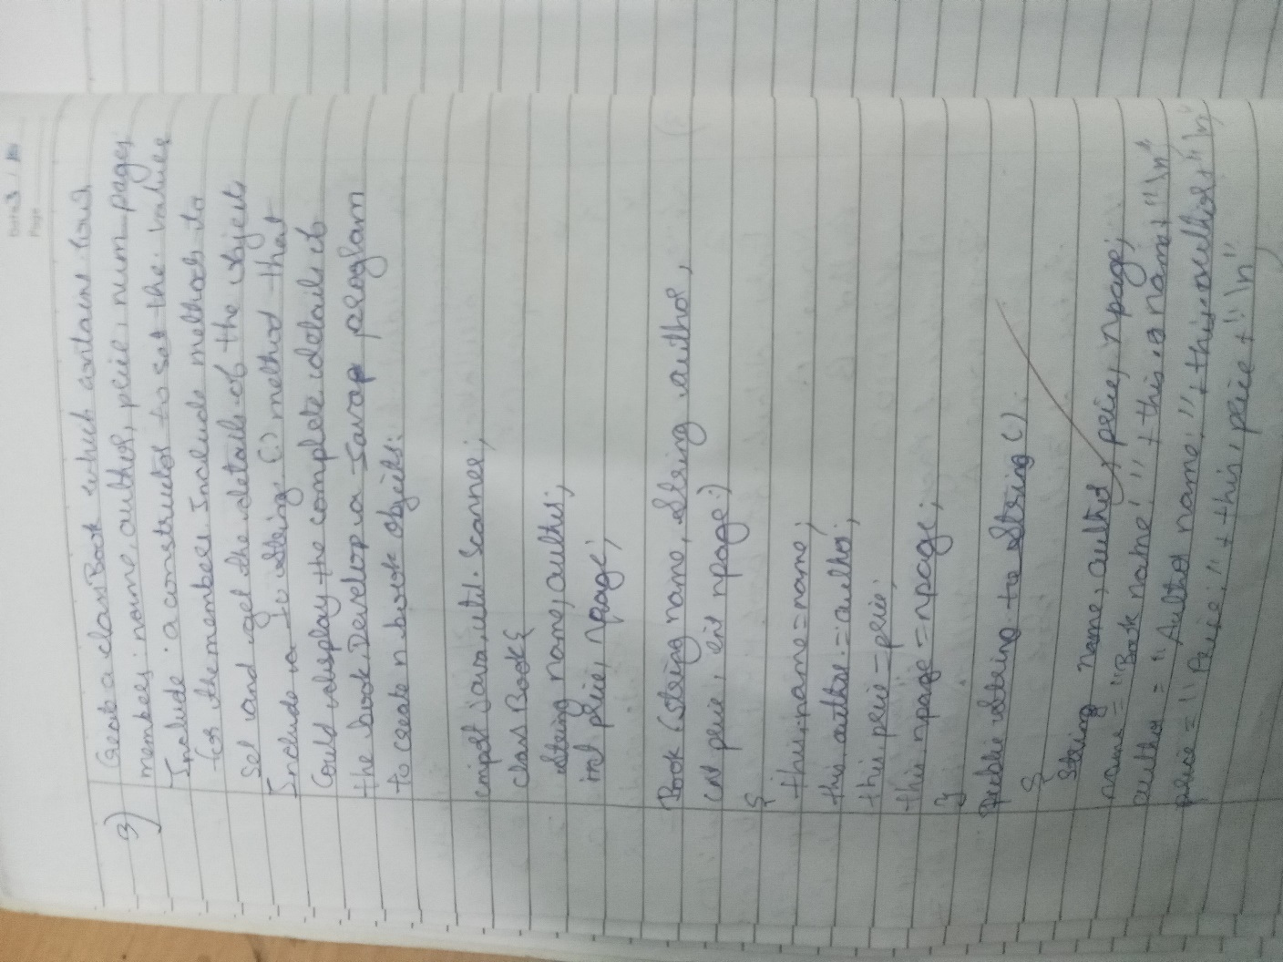

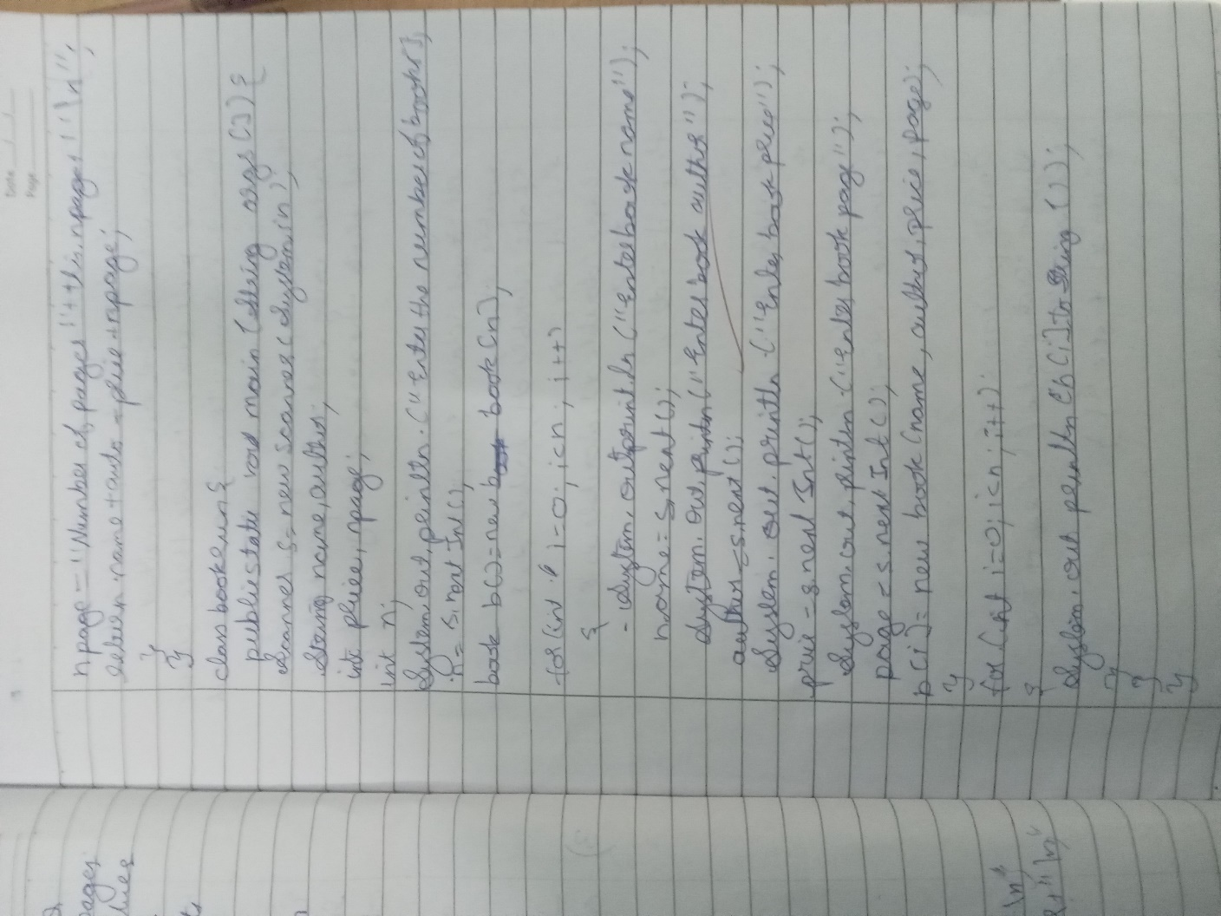

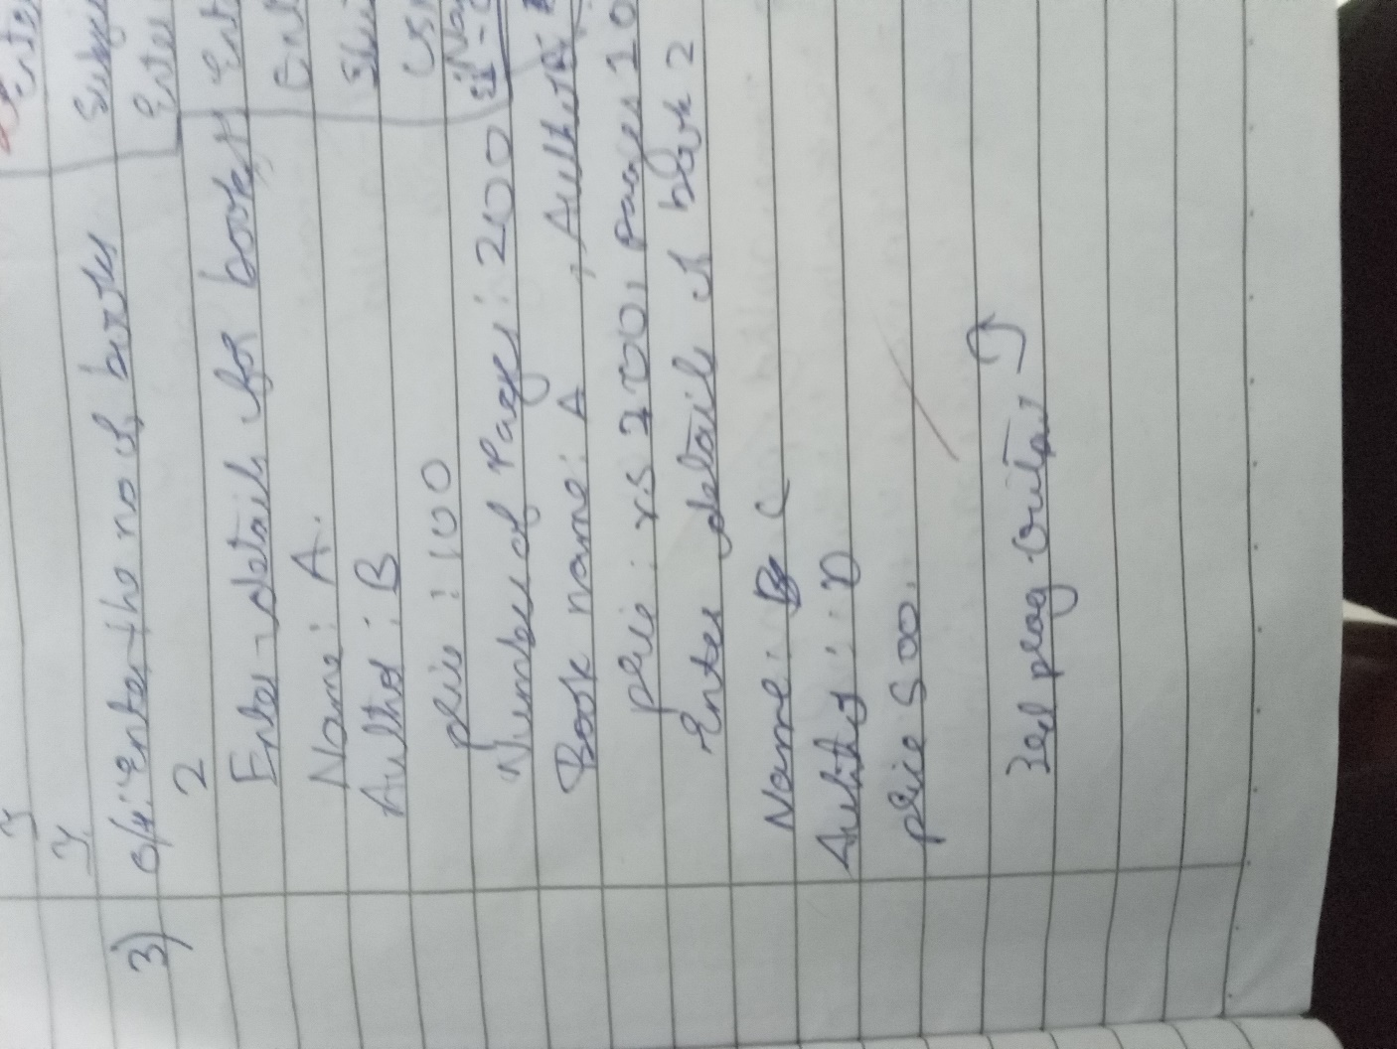

**CODE** **:**

import java.util.Scanner; class Book {

private String name; private String author; private double price; private int numPages;

public Book(String name, String author, double price, int numPages) { this.name = name;

this.author = author; this.price = price; this.numPages = numPages;}

public String getName() { return name;}

public void setName(String name) { this.name = name; }

public String getAuthor() { return author;}

public void setAuthor(String author) { this.author = author;}

public double getPrice() { return price;}

public void setPrice(double price) { this.price = price; }

public int getNumPages() { return numPages; }

public void setNumPages(int numPages) { this.numPages = numPages;}

@Override

public String toString() {

return "Book Name: " + name + "\nAuthor: " + author + "\nPrice: "

+ price + "\nNumber of Pages: " + numPages; } public static void main(String[] args) {

Scanner sc = new Scanner(System.in); System.out.print("Enter the number of books: "); int n = sc.nextInt();

sc.nextLine();

**Book[]** **books** **=** **new** **Book[n];** **for** **(int** **i** **=** **0;** **i** **<** **n;** **i++)** **{**

System.out.println("Enter details for book " + (i + 1) + ":"); System.out.print("Enter Book Name: ");

String name = sc.nextLine(); System.out.print("Enter Author Name: "); String author = sc.nextLine(); System.out.print("Enter Price: ");

double price = sc.nextDouble(); System.out.print("Enter Number of Pages: "); int numPages = sc.nextInt();

sc.nextLine();

books[i] = new Book(name, author, price, numPages);

**}**

System.out.println("\nDetails of all books:"); for (int i = 0; i < n; i++) {

System.out.println("\nBook " + (i + 1) + " Details:"); System.out.println(books[i].toString());

**}**

sc.close();

**}**

**}**

**OUTPUT** **:**

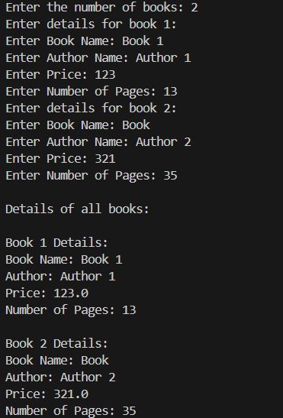

# LABORATORY PROGRAM – 4

Develop a Java program to create an abstract class named Shape that contains two integers and an empty method named printArea( ). Provide three classes named Rectangle, Triangle and Circle such that each one of the classes extends the class Shape. Each one of the classes contain only the method printArea( ) that prints the area of the given shape.

**OBSERVATION** **:**

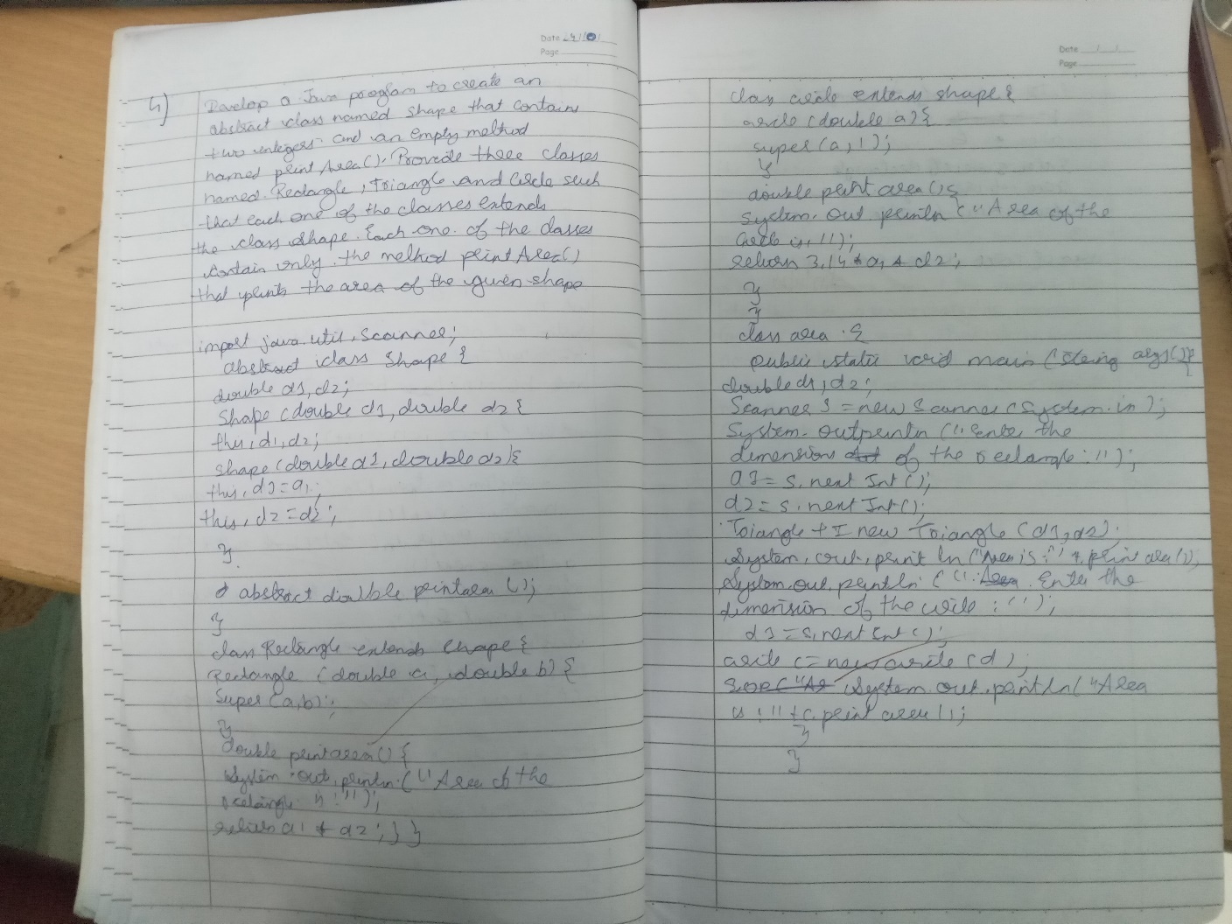

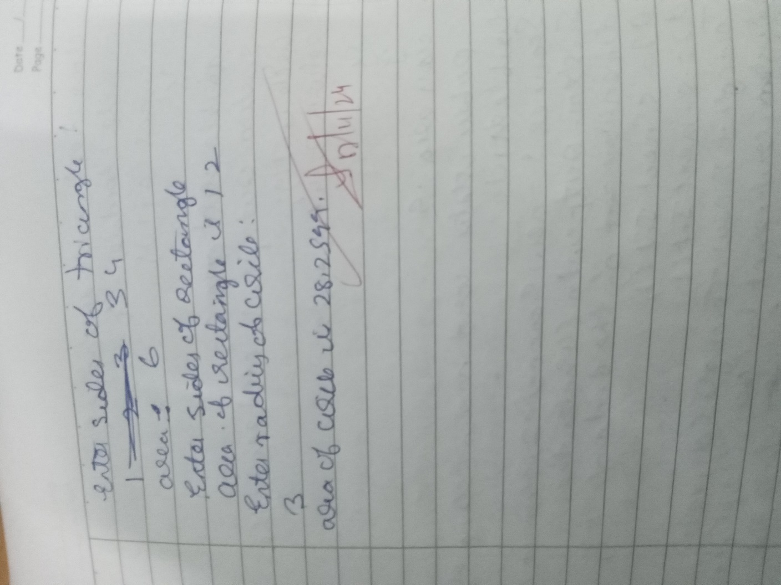

**CODE** **:**

abstract class Shape { int d1;

int d2;

Shape(int d1, int d2) { this.d1 = d1; this.d2 = d2;

**}**

abstract void printArea();

**}**

class Rectangle extends Shape { Rectangle(int l, int b) {

super(l, b);

**}**

void printArea() { System.out.println("Rectangle Shape");

System.out.println("The area is : " + d1 * d2);}} class Triangle extends Shape {

Triangle(int b, int h) { super(b, h);

**}**

void printArea() { System.out.println("Triangle Shape");

System.out.println("The area is : " + 0.5 * d1 * d2);

**}**

**}**

class Circle extends Shape { Circle(int r) {

super(r, 0);

**}**

void printArea() { System.out.println("Circle Shape");

System.out.println("The area is : " + (Math.PI * d1 * d1));}} class ShapeMain {

public static void main(String[] args) { Shape shape;

shape = new Rectangle(5, 2); shape.printArea();

shape = new Triangle(5, 2); shape.printArea();

shape = new Circle(5); shape.printArea();

**}**

**}**

**OUTPUT** **:**

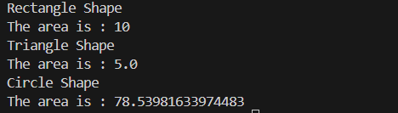

# LABORATORY PROGRAM – 5

Develop a Java program to create a class Bank that maintains two kinds of account for its customers, one called savings account and the other current account. The savings account provides compound interest and withdrawal facilities but no cheque book facility. The current account provides cheque book facility but no interest. Current account holders should also maintain a minimum balance and if the balance falls below this level, a service charge is imposed. Create a class Account that stores customer name, account number and type of account. From this derive the classes Cur-acct and Sav-acct to make them more specific to their requirements. Include the necessary methods in order to achieve the following tasks: a) Accept deposit from customer and update the balance. b) Display the balance. c) Compute and deposit interest d) Permit withdrawal and update the balance Check for the minimum balance, impose penalty if necessary and update the balance.

**OBSERVATION** **:**

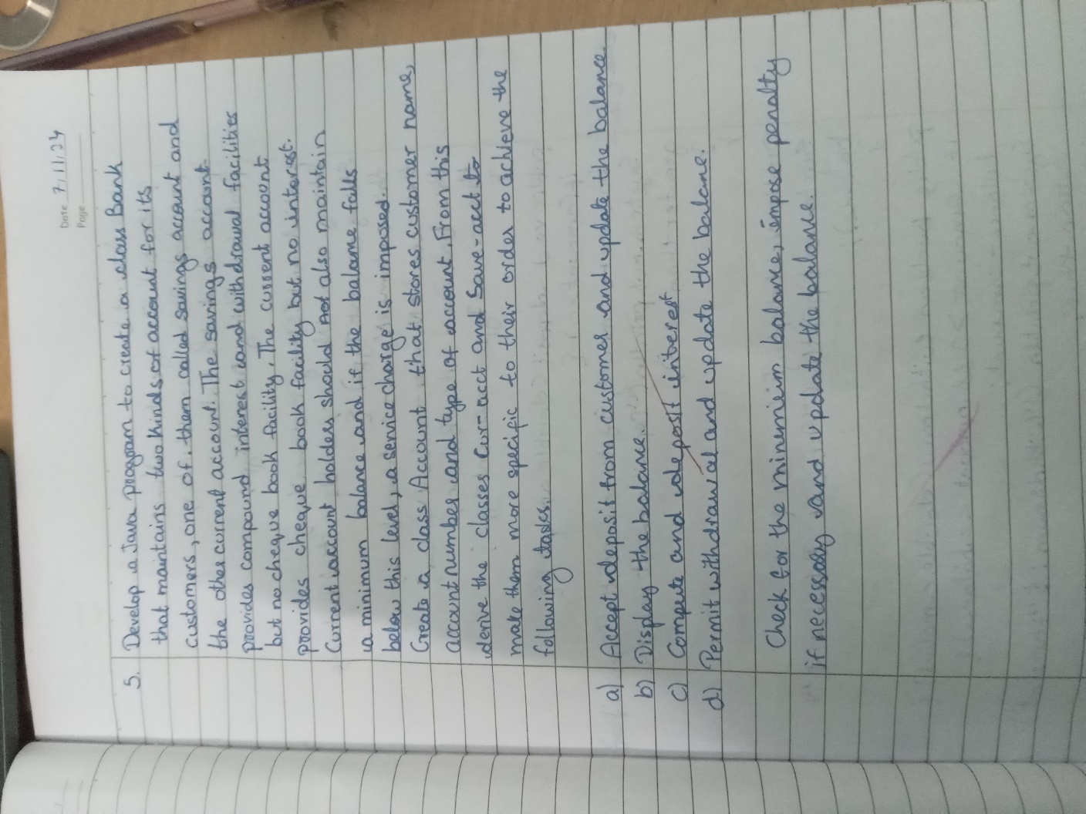

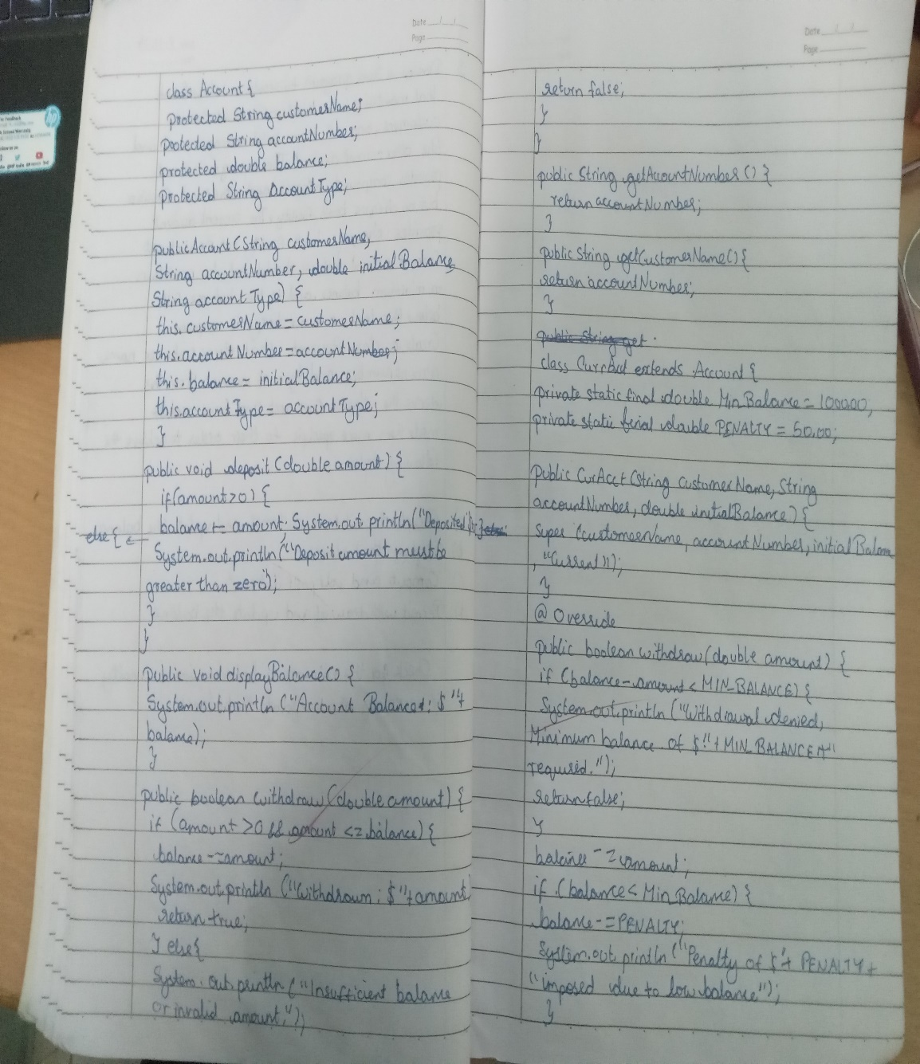

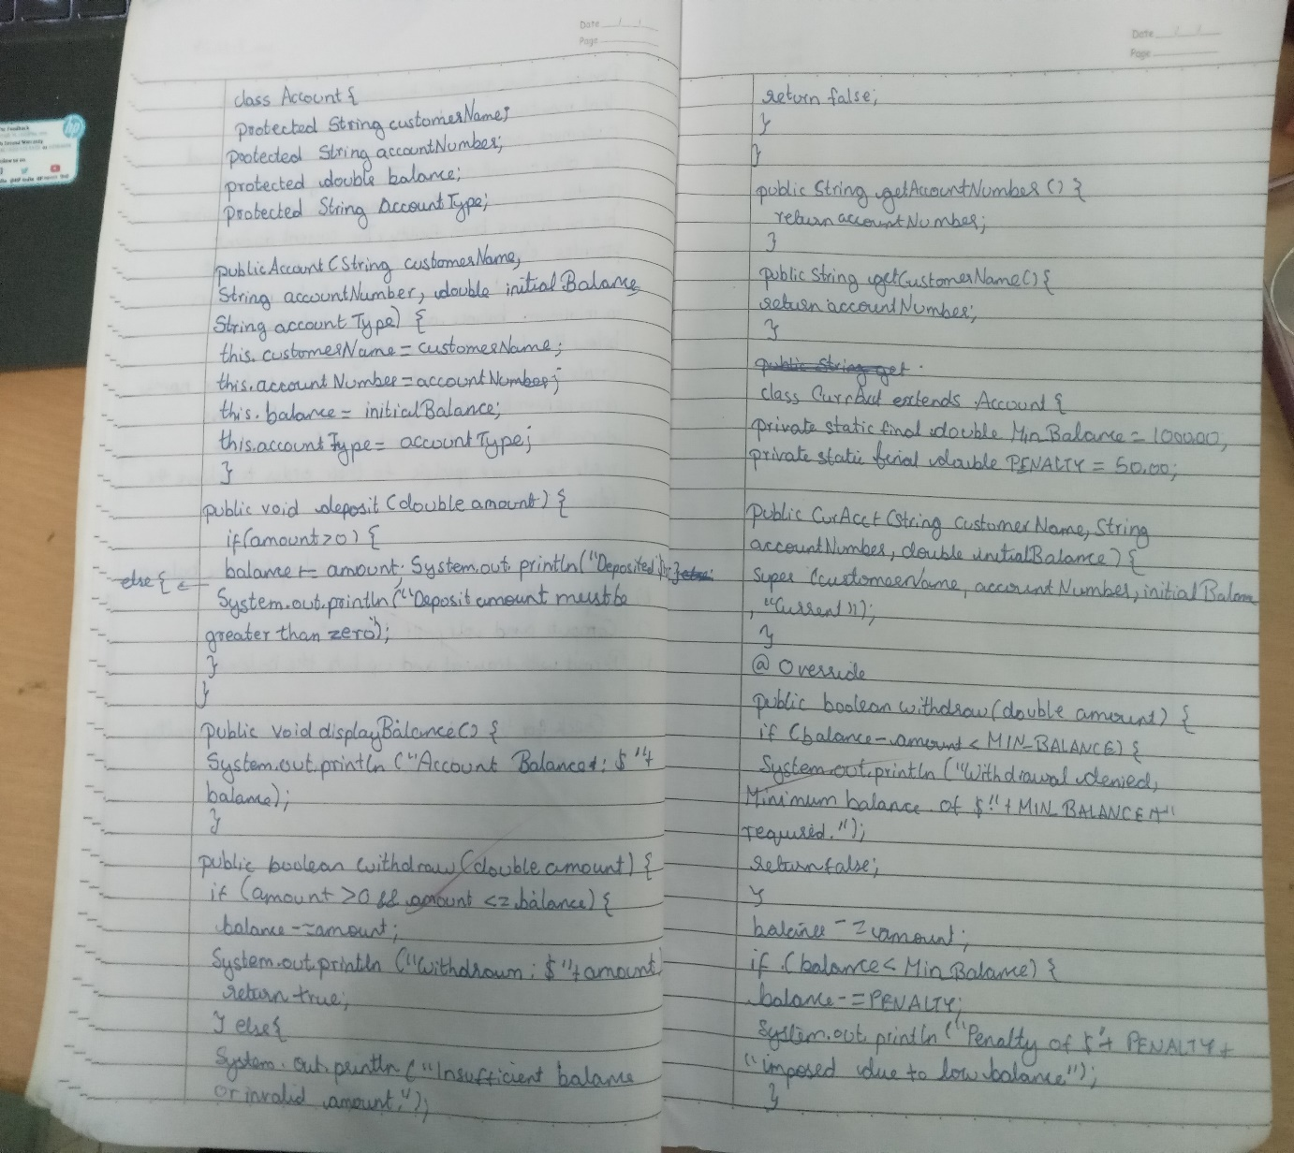

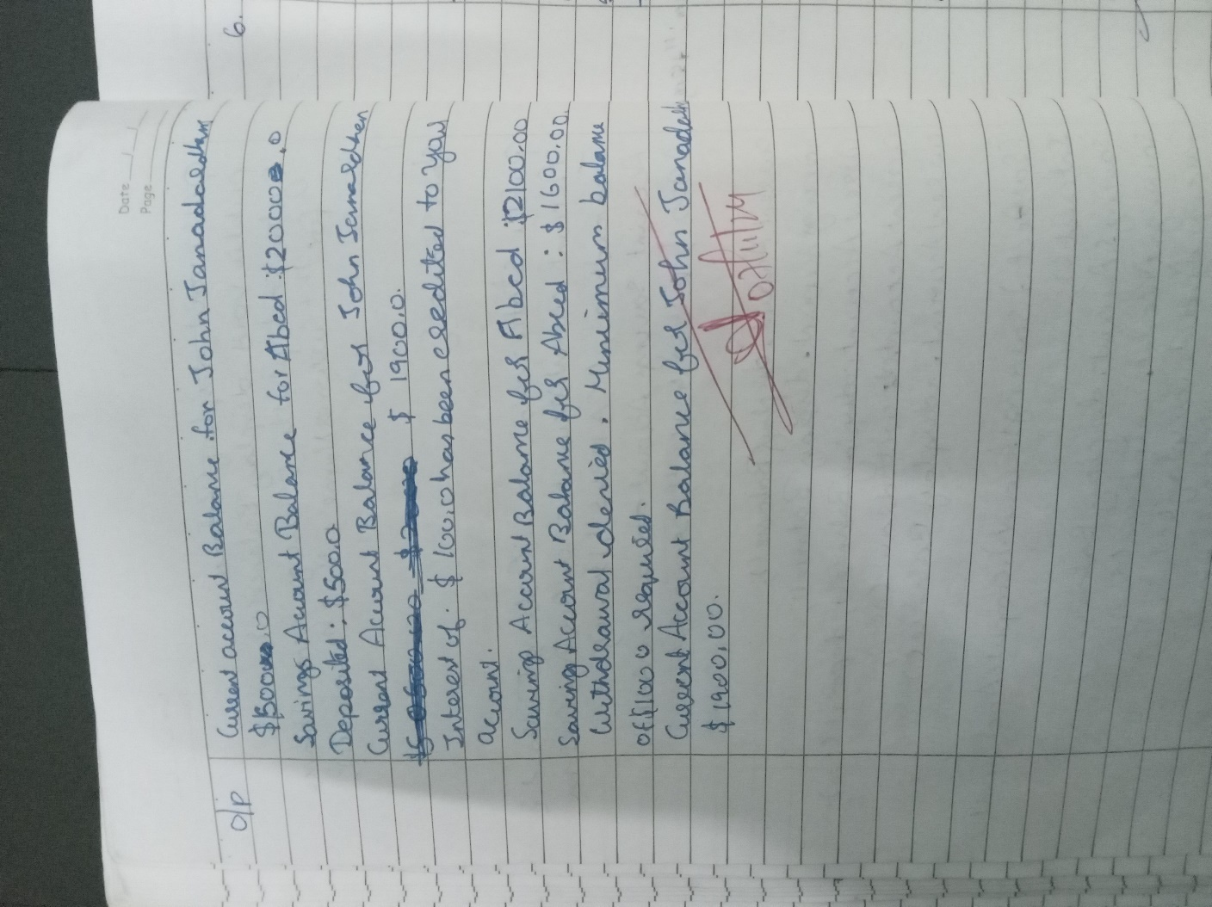

**CODE** **:**

class Account{

String customer_name; long account_no; String typeofAccount; double balance;

Account(String customer_name,long account_no,String typeAccount,double balance){

this.customer_name=customer_name; this.account_no=account_no; this.typeofAccount=typeAccount; this.balance=balance; }

void deposites(double amount){ this.balance+=amount;

System.out.println("Amount of "+amount+" has been debited"); } void displayBalance(){

System.out.println("The Balance Of The "+account_no+" and Name "+customer_name+" is :"+balance); }

void withdraw(double amount){ if(balance<amount){

System.out.println("Insufficient Balance"); }else{ this.balance-=amount;

System.out.println("Amount of "+amount+" succesfully withdrwn");}}}

class SavingAccount extends Account{ double compound_interest=0.04;

SavingAccount(String customername,long account_no){

super(customername,account_no,"SAVINGS",0);} void compoundInterest(){

double interest=balance*0.04; balance+=interest; System.out.println("Intereset deposited");} }

class CurrentAccount extends Account{ boolean chequebook=true;

double minimum_Balance=5000; double service_charge=50;

CurrentAccount(String customername,long account_no){ super(customername, account_no,"CURRENT", 5000); }

void withdraw(int amount){ if(balance>amount){

this.balance-=amount;

System.out.println("Amounte of "+amount+" withdrawed Succesfully");

imposePenalty(); }else{ System.out.println("Insuffescient Balance");}}

void imposePenalty(){ if(balance<minimum_Balance){

balance-=service_charge; System.out.println("Penalty Added");} } }

public class Bank {

public static void main(String[] args) { SavingAccount savingAccount=new

SavingAccount("sushanth",123456789 ); savingAccount.displayBalance();

savingAccount.withdraw(500); savingAccount.deposites(1000); savingAccount.deposites(1000); savingAccount.compoundInterest(); savingAccount.withdraw(1000); savingAccount.displayBalance(); System.out.println();

CurrentAccount currentAccount=new CurrentAccount("likhith",987654321 );

currentAccount.displayBalance(); currentAccount.withdraw(500); currentAccount.deposites(1000); currentAccount.deposites(1000); currentAccount.withdraw(1000); currentAccount.displayBalance(); }

**}** **OUTPUT** **:**

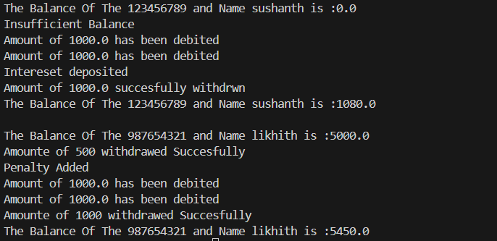

# LABORATORY PROGRAM – 6

Create a package CIE which has two classes- Student and Internals. The class Personal has members like usn, name, sem. The class internals has an array that stores the internal marks scored in five courses of the current semester of the student. Create another package SEE which has the class External which is a derived class of Student. This class has an array that stores the SEE marks scored in five courses of the current semester of the student. Import the two packages in a file that declares the final marks of n students in all five courses.

**OBSERVATION** **:**

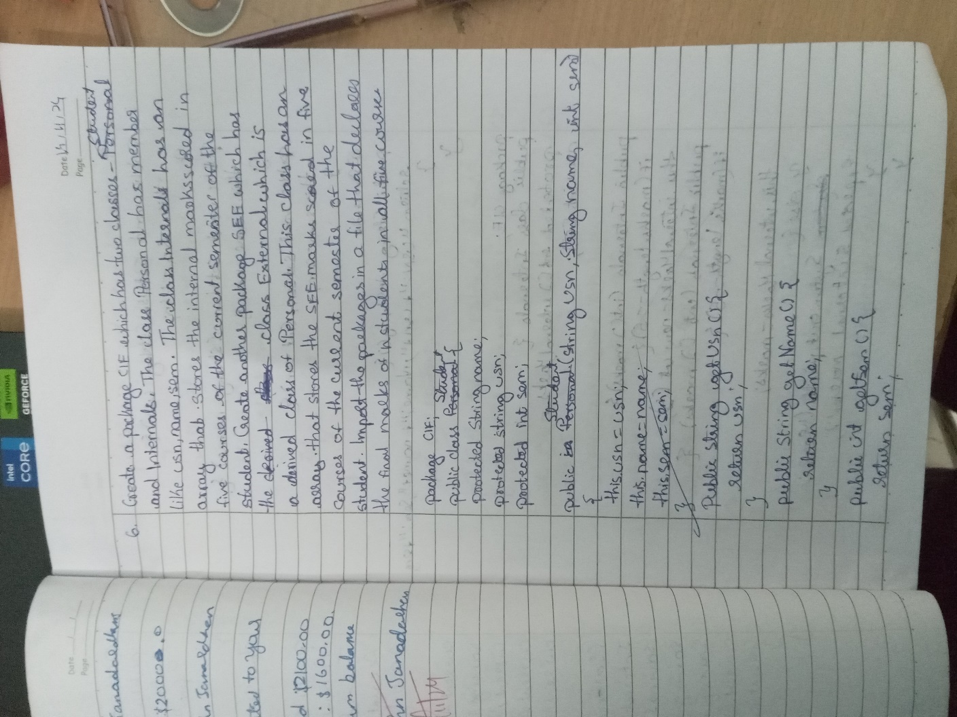

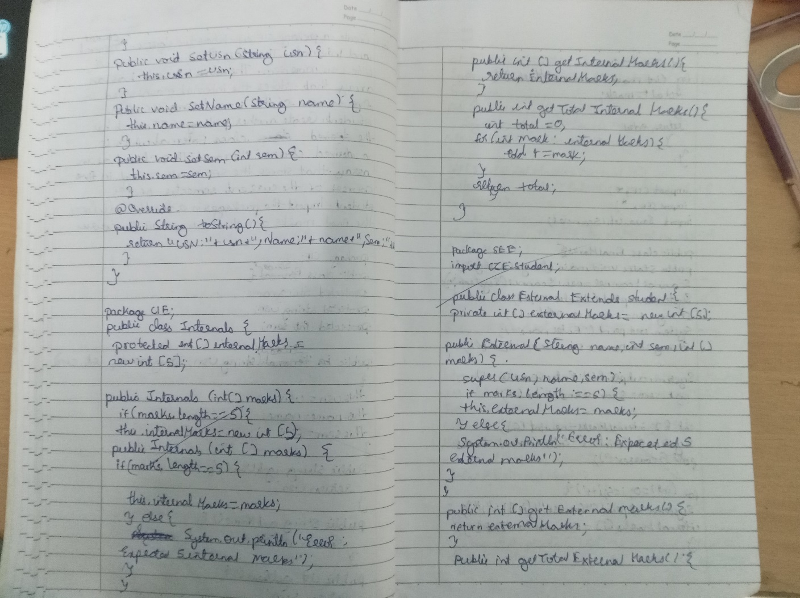

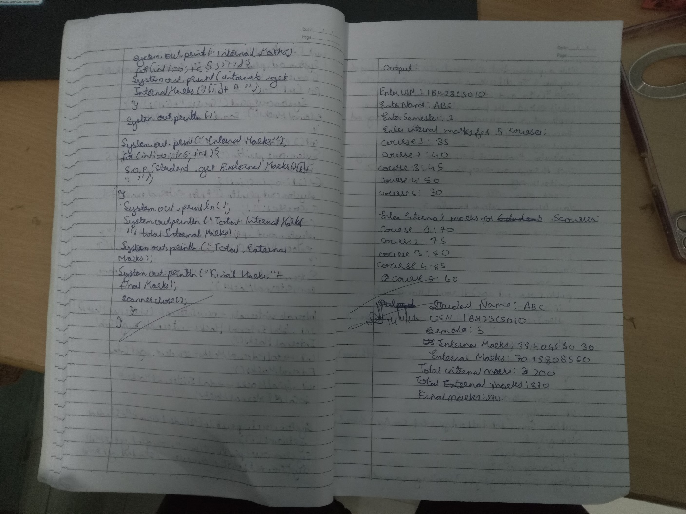

E :

File : CIE/Student.java package cie;

public class Student { public String usn; public String name; public int sem;

public Student(String usn, String name, int sem) { this.usn = usn;

this.name = name; this.sem = sem;

**}**

**}**

File : CIE/Internal.java package cie;

public class Internals {

public int[] internalMarks = new int[5]; public Internals(int[] marks) {

if (marks.length == 5) {

System.arraycopy(marks, 0, internalMarks, 0, 5);

**}** **else** **{**

System.out.println("Error: Please provide marks for exactly 5 courses.");

**}**

**}**

**}**

File : SEE/External.java package see;

import cie.Student;

public class External extends Student { public int[] externalMarks = new int[5];

public External(String usn, String name, int sem, int[] marks) { super(usn, name, sem);

if (marks.length == 5) {

System.arraycopy(marks, 0, externalMarks, 0, 5);

**}** **else** **{**

System.out.println("Error: Please provide marks for exactly 5 courses.");

**}**

**}**

**}**

File : FinalMarrks.java import cie.*;

import see.*;

import java.util.Scanner; public class FinalMarks {

public static void main(String[] args) { Scanner sc = new Scanner(System.in);

System.out.print("Enter number of students: "); int n = sc.nextInt();

Student[] students = new Student[n]; Internals[] internals = new Internals[n];

**External[]** **externals** **=** **new** **External[n];** **for** **(int** **i** **=** **0;** **i** **<** **n;** **i++)** **{**

System.out.println("Enter details for student " + (i + 1) + ":"); System.out.print("USN: ");

String usn = sc.next(); System.out.print("Name: "); String name = sc.next(); System.out.print("Semester: "); int sem = sc.nextInt();

System.out.println("Enter internal marks for 5 courses:"); int[] internalMarks = new int[5];

for (int j = 0; j < 5; j++) { internalMarks[j] = sc.nextInt();

**}**

System.out.println("Enter SEE marks for 5 courses:"); int[] externalMarks = new int[5];

for (int j = 0; j < 5; j++) { externalMarks[j] = sc.nextInt();

**}**

students[i] = new Student(usn, name, sem); internals[i] = new Internals(internalMarks);

externals[i] = new External(usn, name, sem, externalMarks);

**}**

System.out.println("\nFinal Marks of Students:"); for (int i = 0; i < n; i++) {

System.out.println("Student: " + students[i].name + " (USN: " + students[i].usn + ")");

**for** **(int** **j** **=** **0;** **j** **<** **5;** **j++)** **{**

int finalMarks = internals[i].internalMarks[j] + externals[i].externalMarks[j] / 2;

System.out.println("Course " + (j + 1) + ": " + finalMarks);

**}**

**}**

sc.close();

**}**

**}**

**OUTPUT** **:**

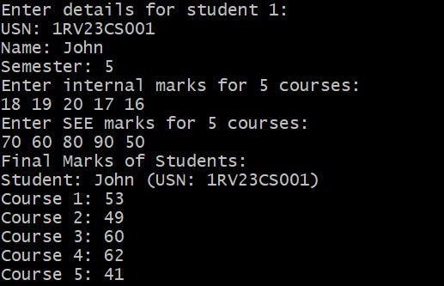

# LABORATORY PROGRAM – 7

Write a program that demonstrates handling of exceptions in inheritance tree. Create a base class called “Father” and derived class called “Son” which extends the base class. In Father class, implement a constructor which takes the age and throws the exception WrongAge( ) when the input age=father’s age.

**OBSERVATION** **:**

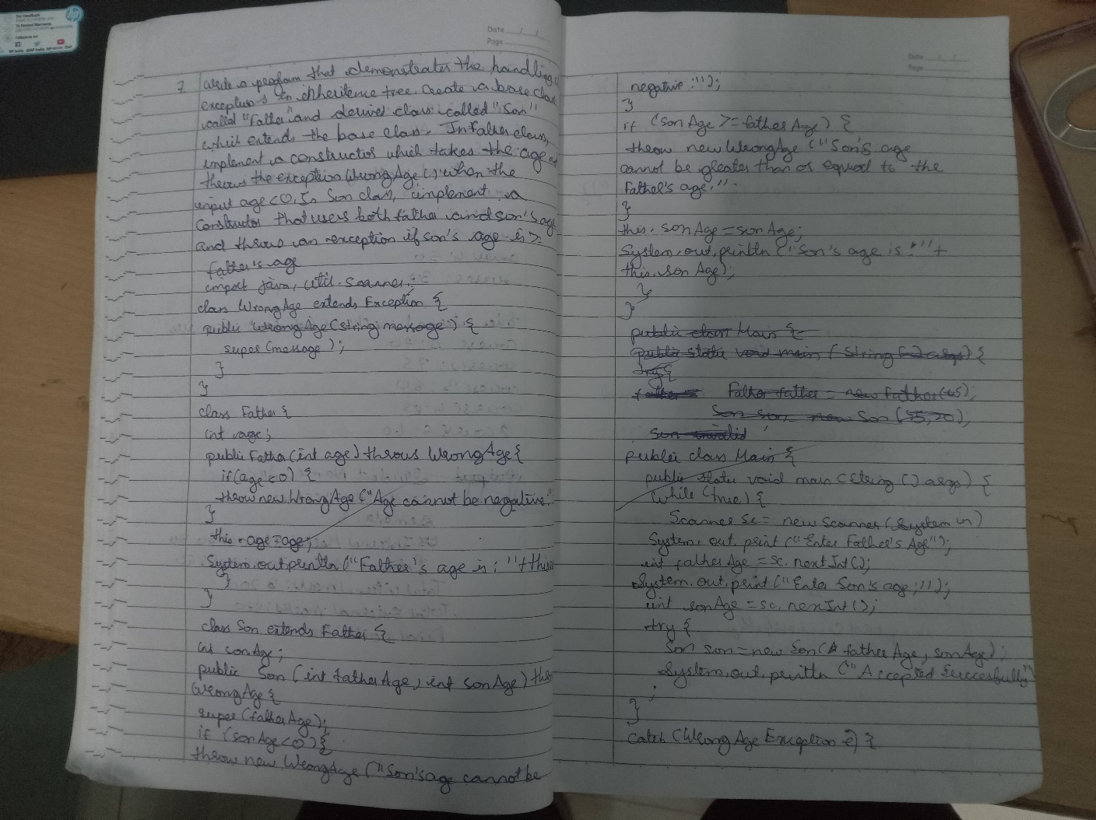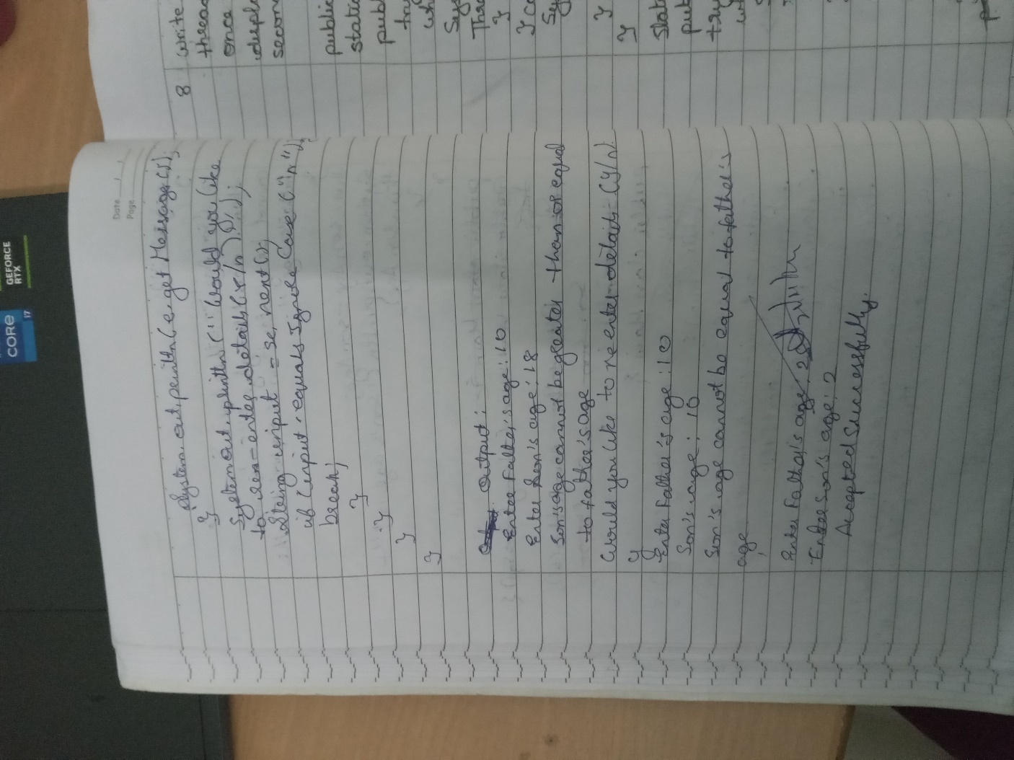

**CODE** **:**

class WrongAgeException extends Exception { public WrongAgeException(String message) {

super(message); } } class Father {

int fatherAge;

public Father(int age) throws WrongAgeException { if (age < 0) {

throw new WrongAgeException("Father's age cannot be negative!");

**}**

this.fatherAge = age;

System.out.println("Father's Age: " + fatherAge); } } class Son extends Father {

int sonAge;

public Son(int fatherAge, int sonAge) throws WrongAgeException { super(fatherAge);

**if** **(sonAge** **<** **0)** **{**

throw new WrongAgeException("Son's age cannot be negative!");

**}**

if (sonAge >= fatherAge) {

throw new WrongAgeException("Son's age cannot be greater than or equal to father's age!");

**}**

this.sonAge = sonAge; System.out.println("Son's Age: " + sonAge); } }

public class ExceptionMain {

public static void main(String[] args) {

java.util.Scanner sc = new java.util.Scanner(System.in); try {

System.out.print("Enter Father's Age: "); int fatherAge = sc.nextInt(); System.out.print("Enter Son's Age: "); int sonAge = sc.nextInt();

Son son = new Son(fatherAge, sonAge);

} catch (WrongAgeException e) { System.out.println("Exception: " + e.getMessage());

} catch (Exception e) {

System.out.println("Unexpected Exception: " + e);} } }

**OUTPUT** **:**

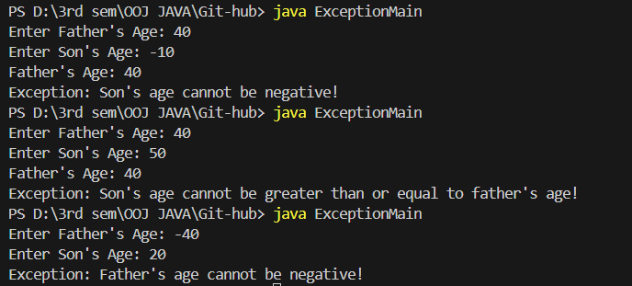

# LABORATORY PROGRAM – 8

Write a program which creates two threads, one thread displaying “BMS College of Engineering” once every ten seconds and another displaying “CSE” once every two seconds.

**OBSERVATION** **:**

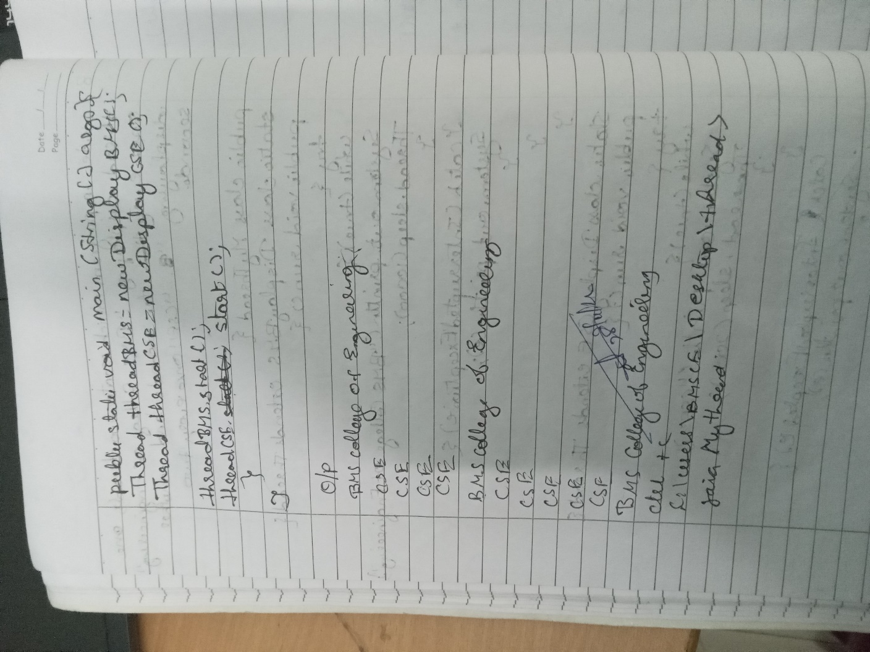

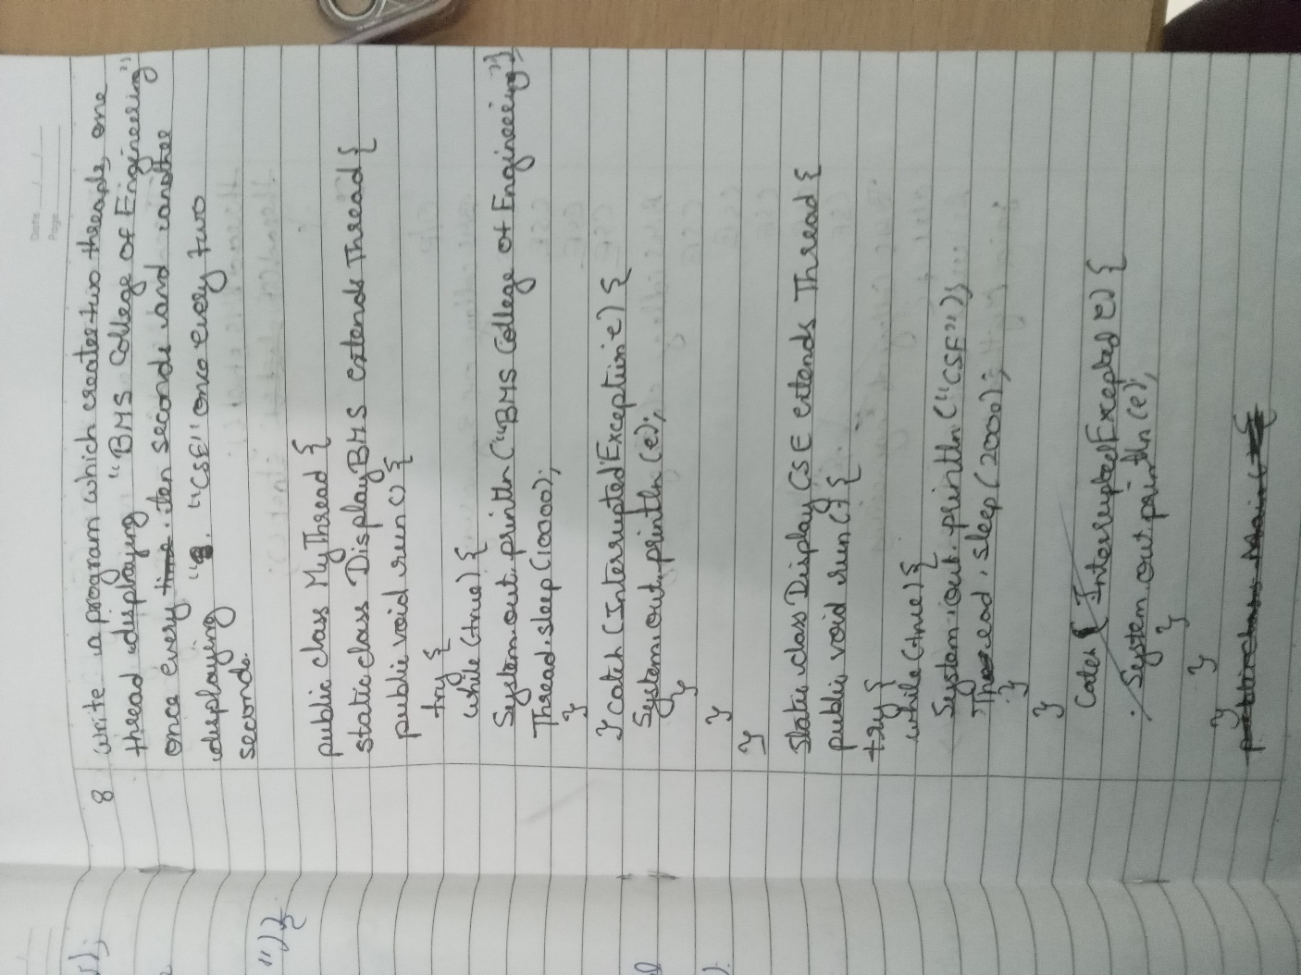

**CODE** **:**

class BmsThread extends Thread{ public void run(){

try{

while (true) {

System.out.println("BMS college of Engineering"); Thread.sleep(10000);

**}**

}catch(InterruptedException e){ System.out.println(e);

**}**

**}**

**}**

class CseThread implements Runnable{ Thread t;

public void run(){ try{

while (true) { System.out.println("Cse"); Thread.sleep(2000);

**}**

}catch(InterruptedException e){ System.out.println(e);

**}**

**}**

**}**

public class DemoThread {

public static void main(String[] args) { BmsThread b=new BmsThread(); Runnable cse=new CseThread(); Thread t1=new Thread(cse); b.start();

t1.start();;

**}**

**}**

**OUTPUT** **:**

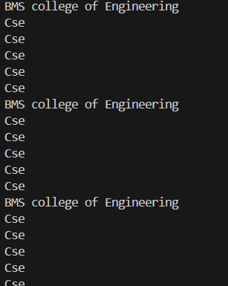

# LABORATORY PROGRAM – 9

Write a program that creates a user interface to perform integer divisions. The user enters two numbers in the text fields, Num1 and Num2. The division of Num1 and Num2 is displayed in the Result field when the Divide button is clicked. If Num1 or Num2 were not an integer, the program would throw a NumberFormatException. If Num2 were Zero, the program would throw an Arithmetic Exception Display the exception in a message dialog box.

**OBSERVATION** **:**

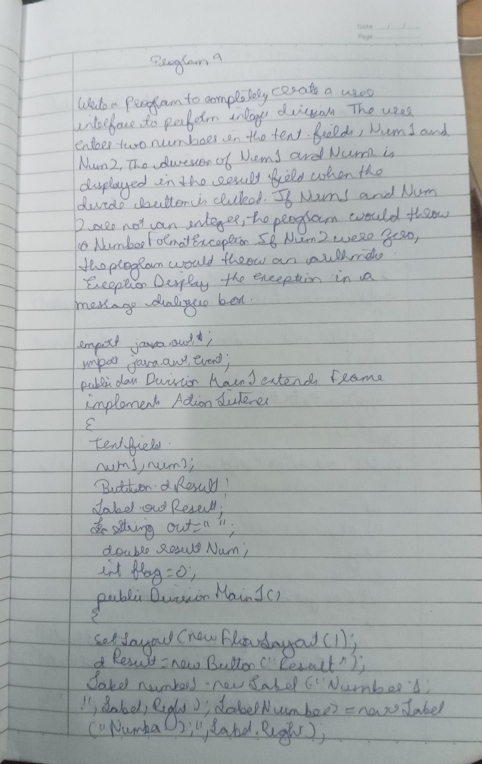

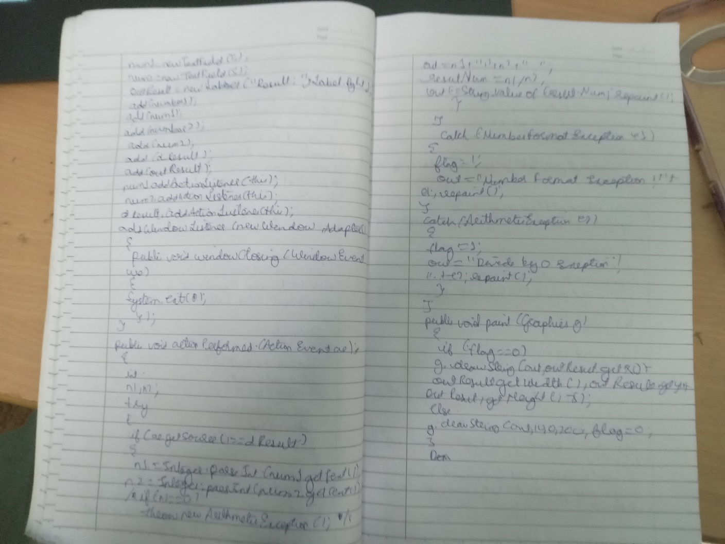

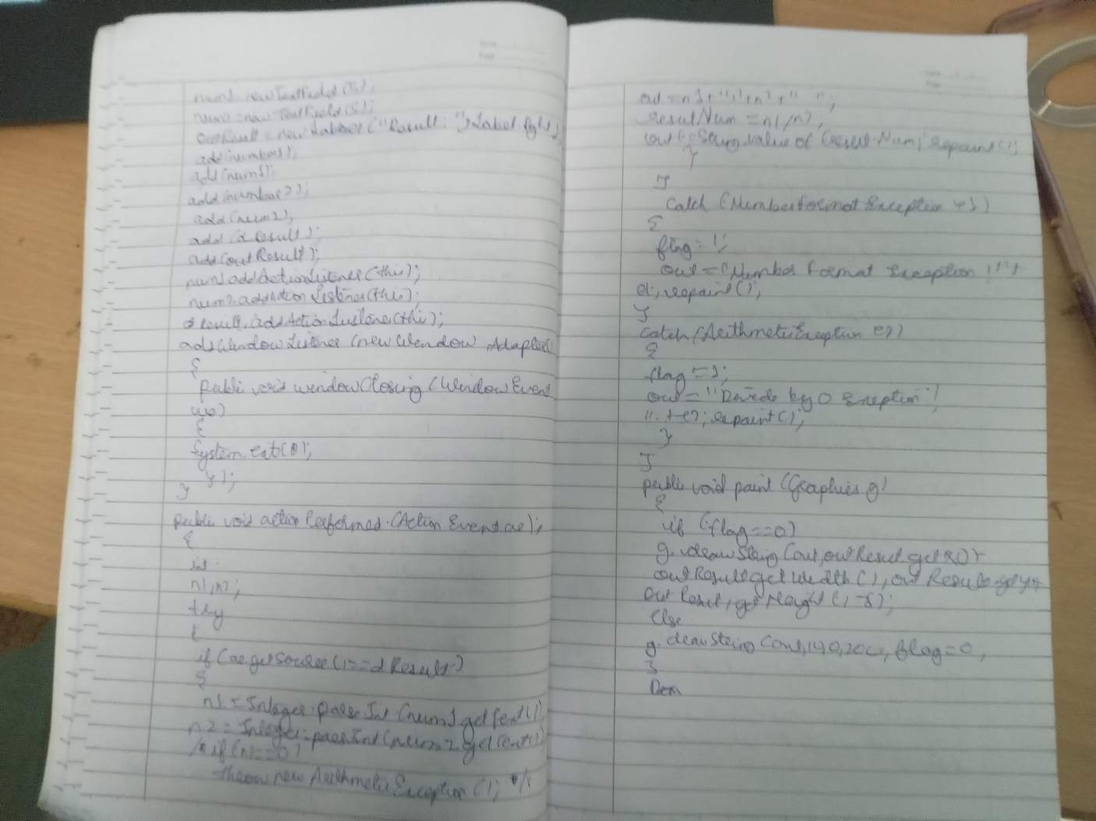

**CODE** **:**

import java.awt.*; import java.awt.event.*;

public class Maindemo extends Frame implements ActionListener { TextField num1, num2;

Button dResult; Label outResult; String out = ""; double resultNum; int flag = 0;

public Maindemo() { setLayout(new FlowLayout());

dResult = new Button("RESULT");

Label number1 = new Label("Number 1:", Label.RIGHT); Label number2 = new Label("Number 2:", Label.RIGHT); num1 = new TextField(5);

num2 = new TextField(5);

outResult = new Label("Result:", Label.RIGHT); add(number1);

add(num1); add(number2); add(num2); add(dResult);

add(outResult); num1.addActionListener(this); num2.addActionListener(this); dResult.addActionListener(this); addWindowListener(new WindowAdapter() {

public void windowClosing(WindowEvent we) { System.exit(0);

**}** **});**

**}**

public void actionPerformed(ActionEvent ae) { int n1, n2;

try {

if (ae.getSource() == dResult) {

n1 = Integer.parseInt(num1.getText()); n2 = Integer.parseInt(num2.getText()); if (n2 == 0) {

throw new ArithmeticException("Division by zero"):} resultNum = (double) n1 / n2;

**out** **=** **n1** **+** **"** **/** **"** **+** **n2** **+** **"** **=** **"** **+** **resultNum;**

**}**

} catch (NumberFormatException e1) { flag = 1;

out = "Number Format Exception! Please enter valid integers.";

} catch (ArithmeticException e2) { flag = 1;

out = "Divide by 0 Exception! " + e2.getMessage();}

repaint();}

public void paint(Graphics g) {

Font customFont = new Font("Serif", Font.BOLD, 20); g.setFont(customFont);

**if** **(flag** **==** **0)** **{**

g.drawString(out, outResult.getX() + outResult.getWidth() + 10, outResult.getY() +20);

**}** **else** **{**

g.drawString(out, 100, 200);

**flag** **=** **0;**

**}** **}**

public static void main(String[] args) { Maindemo dm = new Maindemo(); dm.setSize(new Dimension(800, 400)); dm.setTitle("Division Of Integers"); dm.setVisible(true);

**}**

**}**

**OUTPUT** **:**



# LABORATORY PROGRAM – 10

Demonstrate Inter process Communication and deadlock.

**OBSERVATION** **:**

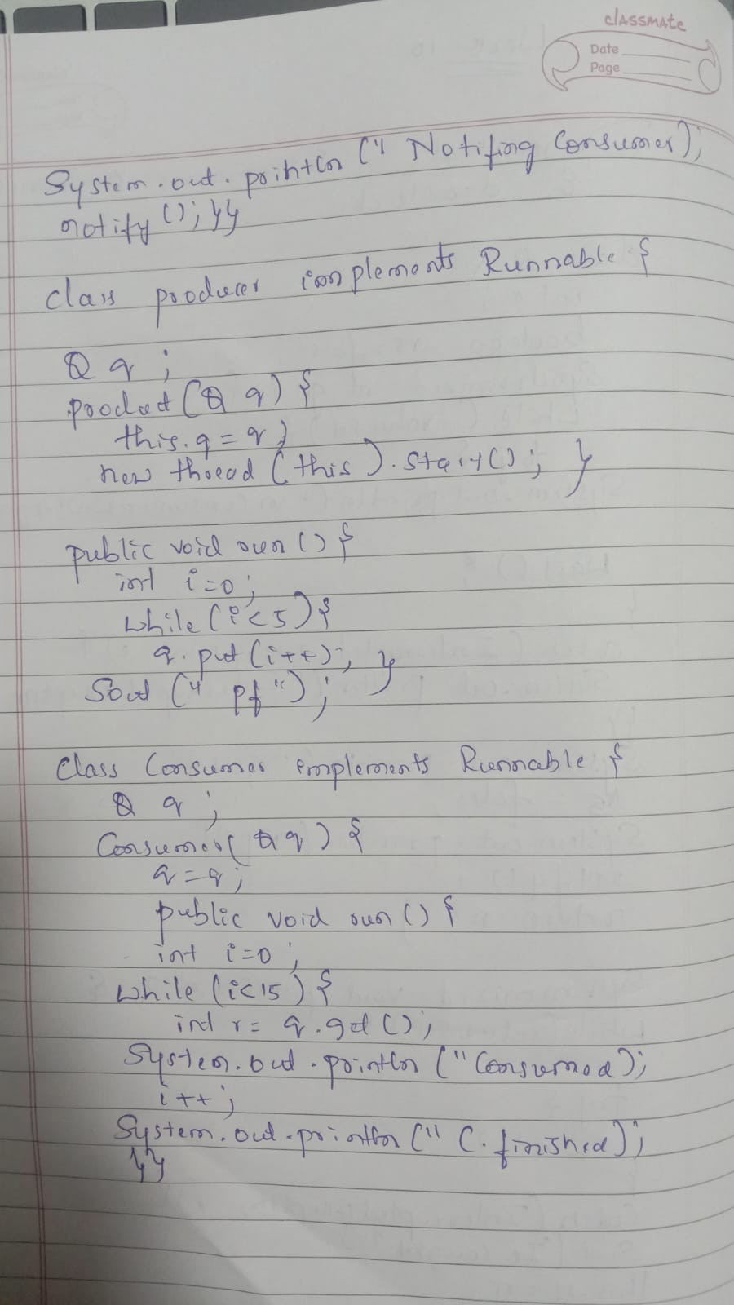

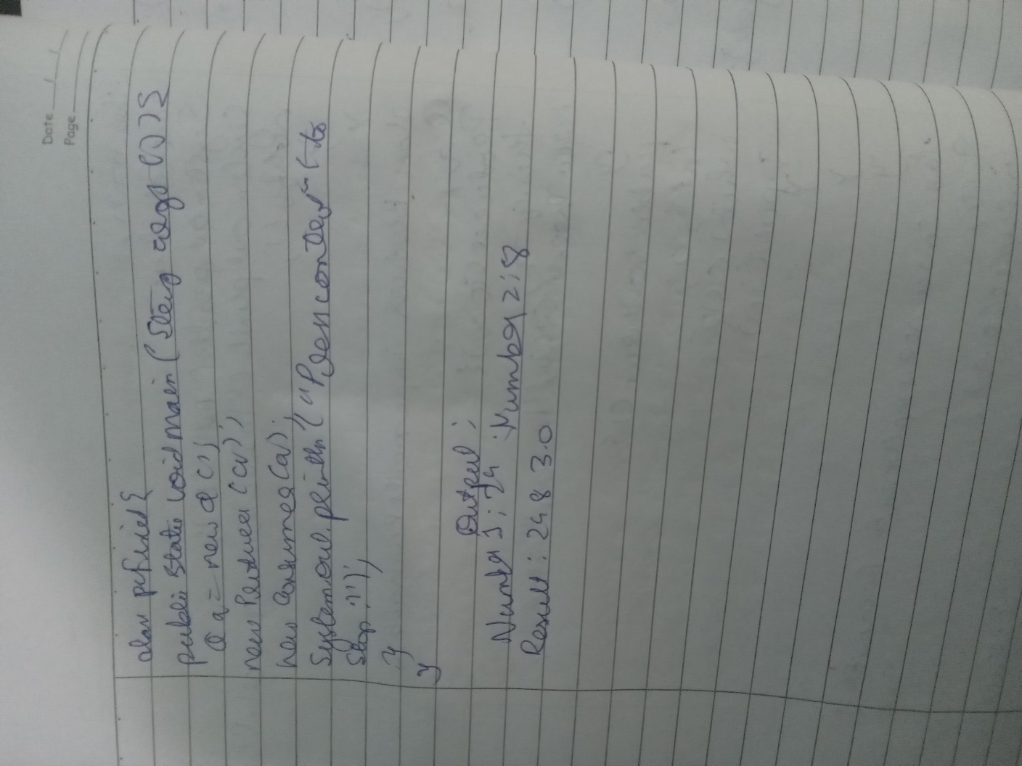

**CODE** **:**

**class** **Q** **{** **int** **n;**

boolean valueSet = false; synchronized int get() {

while (!valueSet) { try {

System.out.println("\nConsumer waiting\n"); wait();

} catch (InterruptedException e) { System.out.println("InterruptedException caught");

**}}**

System.out.println("Got: " + n); valueSet = false;

System.out.println("\nNotifying Producer\n"); notify();

return n;}

synchronized void put(int n) { while (valueSet) {

try {

System.out.println("\nProducer waiting\n"); wait();

} catch (InterruptedException e) { System.out.println("InterruptedException caught"); } }

this.n = n; valueSet = true;

System.out.println("Put: " + n); System.out.println("\nNotifying Consumer\n"); notify(); } }

class Producer implements Runnable { Q q;

Producer(Q q) { this.q = q;

new Thread(this, "Producer").start(); } public void run() {

**int** **i** **=** **0;**

while (i < 15) { q.put(i++); }

System.out.println("Producer finished."); } } class Consumer implements Runnable {

**Q** **q;**

Consumer(Q q) {

this.q = q;

new Thread(this, "Consumer").start(); } public void run() {

**int** **i** **=** **0;**

**while** **(i** **<** **15)** **{** **int** **r** **=** **q.get();**

System.out.println("Consumed: " + r); i++; }

System.out.println("Consumer finished.");

**}** **}**

class PCFixed {

public static void main(String args[]) { Q q = new Q();

new Producer(q); new Consumer(q);

System.out.println("Press Control-C to stop."); } }

**OUTPUT** **:**

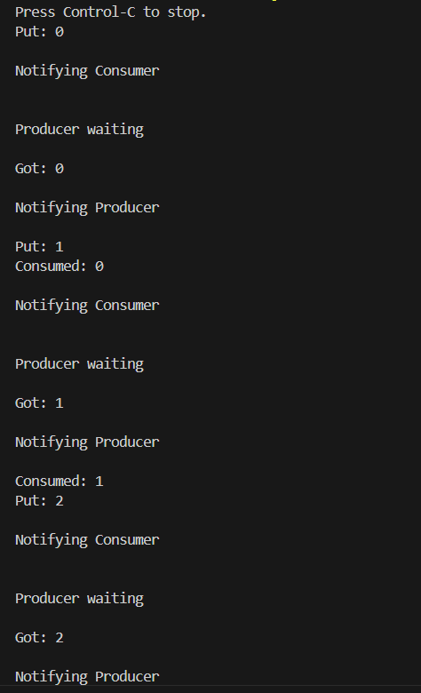

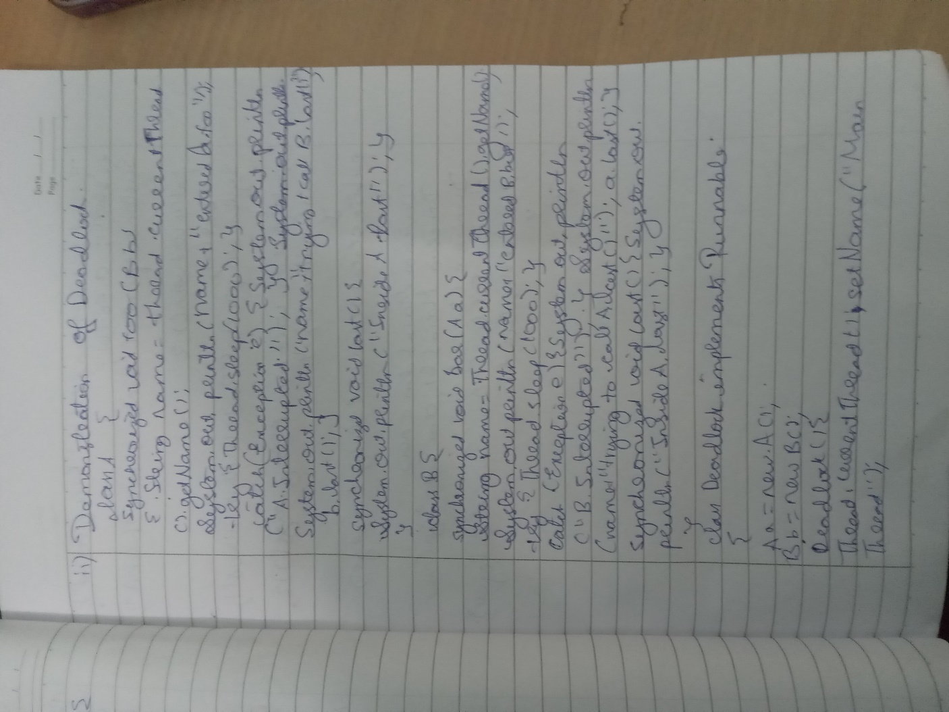

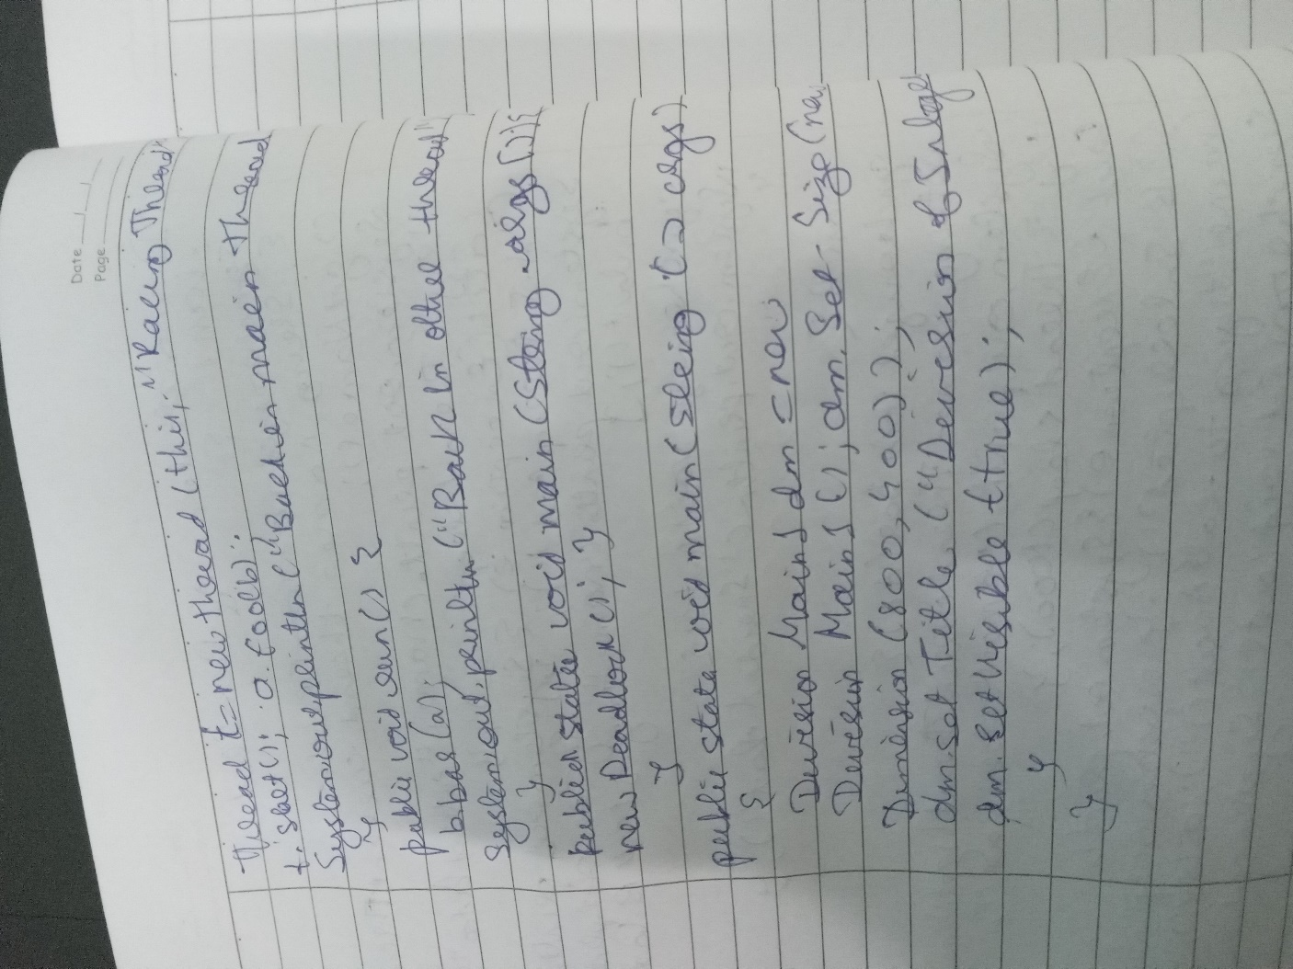

**CODE** **:**

**class** **A** **{**

synchronized void foo(B b) {

String name = Thread.currentThread().getName(); System.out.println(name + " entered A.foo");

try {

Thread.sleep(1000);

} catch (Exception e) { System.out.println("A Interrupted");

**}**

System.out.println(name + " trying to call B.last()"); b.last();

**}**

synchronized void last() { System.out.println("Inside A.last");

**}**

**}**

**class** **B** **{**

synchronized void bar(A a) {

String name = Thread.currentThread().getName(); System.out.println(name + " entered B.bar");

try {

Thread.sleep(1000);

} catch (Exception e) { System.out.println("B Interrupted");

**}**

System.out.println(name + " trying to call A.last()"); a.last();

**}**

synchronized void last() { System.out.println("Inside B.last");

**}**

**}**

class Deadlock implements Runnable {

**A** **a** **=** **new** **A();**

**B** **b** **=** **new** **B();**

Deadlock() { Thread.currentThread().setName("MainThread"); Thread t = new Thread(this, "RacingThread"); t.start();

a.foo(b);

System.out.println("Back in main thread");

**}**

public void run() { b.bar(a);

System.out.println("Back in other thread");

**}**

public static void main(String args[]) { new Deadlock();

**}**

**}**

**OUTPUT** **:**

